|  |
| --- |
| Case Study 3 |
| University Registration System |
| Final Report |

|  |
| --- |
| Created by: Kaitlyn Davis, Nhan Do, Emilio Lopez, Andrew Meyer  4/27/2015 |

**Table of Contents**

Introduction and Problem Statement 3

Initial Requirement Document 4

Software Requirement Specification

1. Introduction 5
   1. Purpose 5
   2. Scope 5
   3. Definitions, Acronyms, and Abbreviations 6
   4. References 6
   5. Overview 6
2. The Overall Description 6-7
   1. Product Perspective 7
      1. System Interfaces 7
      2. Hardware Interfaces 8
      3. Software Interfaces 8
      4. Communication Interfaces 8
      5. Memory Constraints 8
      6. Operations 8
      7. Site Adaptation Requirements 8
      8. Site adaptation requirements 8
   2. Product Functions 9
   3. User Characteristics 9
   4. Constraints 9
   5. Assumptions for Dependencies 9
   6. Apportioning of Requirements 9
3. Specific Requirements 10
   1. External Interfaces
      1. User Interfaces 10-15
      2. Hardware Interfaces 16
      3. Software Interfaces 16
      4. Communication interfaces 16
   2. Functional Requirements
      1. Maintain Member Details 17-20
      2. Maintain Course Details 21-23
      3. Maintain Semester Details 24-25
      4. Maintain Program Details 26-28
      5. Maintain Department Details 29-30
      6. Maintain Login Details 31-32
      7. Login 33-34
      8. Search for a Course 35
      9. Register for a Course 36-37
      10. Drop a course 38
      11. Display Course 39
      12. Display Member 40-41
      13. Generate Report 42-43
      14. Generate Registration Report/Card (Student) 44-45

**Table of Contents**

* 1. Performance Requirements 46
  2. Design Constraints 46
  3. Software System Attributes 46
  4. Logical Database Requirements 46
  5. Other Requirements 46

UML Diagrams

1. Use Case Diagram 47
2. Sequence Diagrams 48-85
3. Class Diagram 86
4. Activity Diagram 87-94
5. Statechart Diagram 95

Project Screenshots and Execution Details 96-97

Test Cases 98-115

Presentation Materials 116

Division of Work 117-118

**Introduction and Problem Statement**

A software is to be developed for automating the functioning of a University registration system (URS). There are four types of members in the system i.e. students, faculty, data entry operator, and administrator. A course will be part of some semester for a particular program, for a particular departments at the university. The URS performs the following functions:

1. **Registration of Students**
   1. Students shall be able to search for courses by name and department.
   2. Students may enroll in courses per the allowed range of credits and if the student meets the requirements for the course.
   3. Courses may be dropped by a student.
   4. If the number of students enrolled in a course equals the course capacity, students cannot register for that course.
2. **Maintenance of Information**
   1. Details of all members with their name, demographics, unique identification number, and more.
   2. Details of all courses with its title, course number, faculty member, department, program, capacity, number of credits, total students enrolled, and more.
   3. Details of a department, including the department name.
   4. Details of a program with duration, degree level, department, program title, and more.
   5. Details of login information including username, password, and role.
   6. Details of a semester, involving the program, semester number, and total credits allowed to be taken.
   7. Details of student enrollment in courses

**Initial Requirement Document**

|  |  |
| --- | --- |
| **Title of the Project** | University Registration System (URS) |
| **Stakeholders Involved in Capturing Requirements** | Students, Project Team Members |
| **Techniques Used for Requirement Capturing** | Brainstorming |
| **Name of the Persons along with Designations** | Kaitlyn Davis, Nhan Do, Emilio Lopez, and Andrew Meyer |
| **Date** | February 2015 |
| **Version** | 1.0 |
| **Consolidated list of Initial Requirements:**   1. A system is to be implemented which can run on the University’s network. 2. The system shall be able to generate Login ID and Password to system operator. 3. There are three types of members in the registration system: student, faculty, data entry operator, and administrator. 4. The administrator and data entry operator shall be able to maintain details of all courses. 5. The administrator and data entry operator shall be able to maintain details of all members of the registration system. 6. The administrator shall be able to create and modify a course. 7. The students shall be able to add and drop from a course. 8. The faculty and students shall be able to search and view courses. 9. The student/faculty shall access the URS on the university’s network. 10. The system shall be able to provide the availability of a particular course. 11. The administrator will be able to maintain semester, program, login, and department details. 12. Students shall be able to see what courses they are taking during a semester. 13. The system should also be able to generate reports like:     1. Details of all courses in the system     2. Details of all members in the system     3. Details of course enrollment     4. Details of a student’s registration | |

**Software Requirement Specification**

1. **Introduction**
   1. **Purpose**

The University Registration System (URS) maintains information about various courses available at the University. The URS also maintains all student and faculty records as they pertain to the courses at the University. These records are maintained in order to provide detailed information on courses.

* 1. **Scope**

The name of the software is University Registration System**.** The system will be referred to as URS in the rest of the SRS. The proposed URSmust be able to perform the following functions:

**Do**

* Maintain details of the following:
  + Login
  + Members
  + Course
  + Semester
  + Department
  + Program
* Register for a course
* Drop a course
* Search for a course using the course designation.
* Generate a student’s registration
* Generate the following reports:
  + Course Registration of a Student
  + Details of a Course
  + All students’ Course Information
  + List All Courses

**Don’t**

* Financial aid data is handled by the bursar’s office
* Course auditing is not covered

**Benefits**

The URS provides the following benefits:

* Easy searching of courses
* Printing of reports
* Efficient enrollment and drop of courses
* Accurate course enrollment details
  1. **Definition, acronyms, and abbreviations**

The definitions and acronyms used in URS are given as:

* Administrator: Any candidate who maintains the URS database at a high and low level of detail.
* Faculty: Any candidate who is a professor in a department of the university
* FERPA: Family Educational Rights & Privacy Act of 1974
* ID: Identification
* IEEE: Institute of Electrical and Electronics Engineers
* RAM: Random Access Memory
* SRS: Software Requirement Specification
* Student: Any candidate admitted in a program offered by the school
  1. **References**
* IEEE Std. 830-1998 and 829-1998
* CSCI-45200 Requirement Analysis.pdf : http://cs.iupui.edu/~ruchmalh/CS45200/
  1. **Overview**

This software system will handle courses students may enroll in at a university. It allows for students to register or drop a course. Administrators and data entry operators members will be to maintain course and member information. Student and faculty will be able to view detail information about courses in the system. The administrator will maintain the system’s database and generate reports pertaining to course information.

The software will use an C# front end with a Access database backend for ease of use for all members of the system. The system will be located on a hub of computers at the university.

This SRS is further detailed into the fine points of this database, starting with how the system will be developed, what interfaces the student, faculty, data entry operator, and administrator will when interacting with the system, and what hardware constraints this system requires for running properly.

After that, the SRS delves into the primary functions of the system in the form of use cases. Any operation a student, faculty, data entry operator, or administrative member can do in the system is described there.

Finally, more system requirements are described below the use cases, along with the basic standards compliance of the system.

1. **The Overall Description**

The URS maintains login, member, semester, program, and department details at the university. It is assumed that all students have already been admitted into a particular program at the university before insertion into the system. The administrator and data entry operator handle the insertion of courses, students, and faculty into the system as per information given from the university.

The URS allows for the registration and drop of courses for a student. The URS handles the tracking of courses taken across semesters in a year. The student/faculty can search for the information of a course for the current semester. The data entry operator will maintain the following information:

* Course details
* Member details

The administrator will have to maintain the following details:

* Course details
* Member details
* Program details
* Semester details
* Department details
* Login details

The administrator will be able to generate reports on:

* A student’s course registration
* All students’ course registration for the current semester
* All courses in the database
* Details of a particular course

The students will be able to perform the following functions:

* Course registration
* Course drop
* Search for a course
* View their course registration
  1. **Product perspective**

The URSshall be developed using client/server architecture and will be compatible with Microsoft Windows Operating System. The front end of the system will be developed using C# while the backend will also be created in Microsoft Access.

Front End Client Application

(Create/Modify, Search, Drop, Reporting facility)

Backend Database

* + 1. **System interfaces**

None

* + 1. **Interfaces**

The URS will have the following user-friendly and menu driven interfaces:

1. **Login**: to allow the entry of only authorized users through valid username and password.
2. **Course** **Details**: to maintain course details.
3. **Semester** **Details**: to maintain semester details.
4. **Program** **Details**: to maintain program details.
5. **Login** **Details**: to maintain login details.
6. **Member** **Details**: to maintain student/faculty details.
7. **Department** **Details**: to maintain department details.
8. **Register** **for a Course**: to allow students to register for a course.
9. **Search for a Course**: to allow faculty/students to search for a course.
10. **Drop a Course**: to allow students to drop a course.
11. **Display Member**: to display faculty/student details
12. **Display Course**: to display course details
13. **Generate Registration Report**: to generate a student’s registration report.
14. **Generate Report**: to generate the following information
    1. A student’s course registration
    2. All students’ course registration for the current semester
    3. All courses in the database
    4. Details of a particular course
       1. **Hardware interfaces**
15. Screen resolution of at least 600 x 800 or above
16. Support for printer (dot matrix, deskjet, lasterjet)
17. Computer systems will be in a networked environment as it is a multi-user system.
    * 1. **Software interfaces**
18. Microsoft Windows Operating System (Vista/7/8/8.1)
19. Microsoft Visual Studios 2013 for designing front-end
20. Microsoft Access 2013 for backend.
    * 1. **Communication interfaces**

This system will use a LAN connection for communication.

* + 1. **Memory constraints**

At least 512MB of RAM and 1GB of hard drive space is required to run this software.

* + 1. **Operations**

This system will support basic backup and recovery options. Data processing support will be handled by the IT support staff at the university for this system.

* + 1. **Site adaptation requirements**

The terminal(s) at the client site will have to support the hardware and software interfaces specified in sections 2.1.3 and 2.1.4 respectively.

* 1. **Product functions**

The URS will allow access only to authorized users with specific roles (administrator, data entry operator, student, faculty). Depending on the user’s roles, they will be able to access only specific parts of the system:

* A login facility for enabling only authorized access to system.
* The administrator will be able to maintain login, member, course, semester, program, and department details, along with generating reports from the URS.
* The data entry operator shall be able to maintain course and member details.
* The faculty shall be able to search courses and view their member information.
* The student shall be able to search, drop, and register for courses, along with being able to view their member information and generate their registration report for a semester.
  1. **User characteristics**
* Qualification: At least matriculation and comfortable with English.
* Experience: Should have a basic understanding of registering for courses at a university.
* Technical Experience: Elementary knowledge of computers.
  1. **Constraints**

The following constraints may limit the developer’s implementation options:

* Family Educational Rights & Privacy Act of 1974 (FERPA)
* Hardware limitations
* Interface to other applications
* Parallel operations
* Control functions
* Higher language functions
* Safety, security, and criticality of the applications
  1. **Assumptions for dependencies**

The developers assume for following while creating this system:

* Billing and payroll features related to the student/faculty members of the university will be handled by the bursar’s office.
* The admission’s office will handle the conversion of courses into the university’s equivalent for transfer students. This system will only deal with courses all students enroll in at this university.
* The department of a course will audit said course(s).
  1. **Apportioning of Requirements**

Not Required.

1. **Specific requirements**

This section contains the software requirements in detail along with the various forms to be developed.

* 1. **External interfaces**

**3.1.1 User interfaces**

The following user-interfaces (or forms) will be provided by the system:

i. **Login**

This will be the first format displayed. It will allow users to access the different forms based on their role.

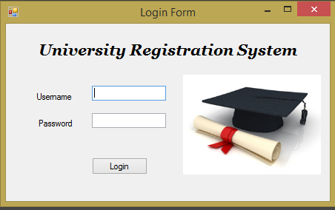

Various fields available on this form will be:

* *Username*: Alphanumeric with a length between 3 and 20 characters.
* *Password*: Alphanumeric with a length between 5 and 50 characters. Any characters allowed.

**ii. Maintain Member Details**

This form will be accessible only to the system administrator and data entry operator. It will allow them to create/modify/delete/view information about existing students and faculty members at the university.

Various fields available on this form will be:

For Students:

* *Student_ID*: An auto-generated number.
* *First Name:* Can have a max length of 40 characters.
* *Last Name:* Can have a max length of 40 characters.
* *Department:* will display all department names at university.
* *Date of Admission: A valid date in the*
* *Program*: will display all programs offer at the university.
* *Email:* Can consist of characters, numbers, and some special characters. Can be at max length of 80 characters.
* *Current Semester:* Number.
* *Current Credit Hours:* Will not be high can the total credit hours possible in the semester of the program the student is currently in.
* *Phone Number:* Will be formatted to the standard (###)###-#### format. Numbers only.

For Faculty:

* *Faculty_ID*: An auto-generated number.
* *First Name:* Can have a max length of 40 characters.
* *Last Name:* Can have a max length of 40 characters.
* *Department:* will display all department names at university.
* *Email:* Can consist of characters, numbers, and some special characters. Can be at max length of 80 characters.
* *Phone Number:* Will be formatted to the standard (###)###-#### format. Numbers only.

**iii. Maintain Course Details**

This form will be accessible only to the system administrator and data entry operator. It will allow them to create/modify/delete/view information about existing courses at the university.

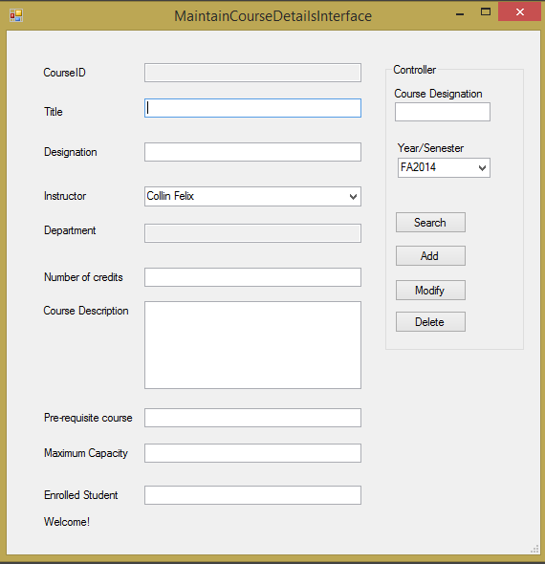

Various fields available on this form will be:

* *Course_ID*: An auto-generated number.
* *Title:* The title of the course. Can have a max length of 50 characters.
* *Course Designation:* A unique string that can identify a course. Consists of characters and numbers.
* *Instructor:* A drop down menu of instructors to select. A course only has 1 teacher.
* *Department:* The department the course is under. The course will be from the same department as the instructor.
* *Number of Credits:* The number of credits a course is worth. Must be greater than 0.
* *Course Description*: Description of course. May be between 0 and 255 characters.
* *Pre-requisite Course:* Must be the course_id of an existing course in the database.
* *Maximum Capacity:* Must be between 1 and 300.
* *Enrolled Students:* The number of enrolled students must be less than or equal to the maximum capacity.

**iv. Maintain Semester Details**

This form will be accessible only to the system administrator. It will allow them to create/modify/delete/view information about existing semester for a particular program at the university.

Various fields available on this form will be:

* *Semester_ID*: An auto-generated number.
* *Semester Number:*  Number
* *Program:* will display all programs at the university.
* *Total Credits Possible:* Number only. The total number of credits a student in a particular semester of a particular program may take.

**v. Maintain Program Details**

This form will be accessible only to the system administrator. It will allow them to create/modify/delete/view information about existing program in a particular department at the university.

Various fields available on this form will be:

* *Program_ID*: An auto-generated number.
* *Program Title:* Can have a max length of 60 characters.
* *Department:* will display all departments at the university.
* *Duration:* In years. Number only. Must be greater than 0.
* *Number of Semesters:*Number only. Must be greater than 0.
* *Degree Level:* Can either be BS, BA, or MS.

**vi. Maintain Department Details**

This form will be accessible only to the system administrator. It will allow them to create/modify/delete/view information about existing department at the university.

Various fields available on this form will be:

* *Department_ID*: An auto-generated number.
* *Department Name:*  Name of department . Can have a max length of 60 characters.

**vii. Maintain Login Details**

This form will be accessible only to the system administrator. It will allow them to create/modify/delete/view information about existing login at the university.

Various fields available on this form will be:

* *Login_ID*: An auto-generated number.
* *Username*: Alphanumeric with a length between 3 and 20 characters.
* *Password*: Alphanumeric with a length between 5 and 50 characters. Any characters allowed.
* *Role*: May only be student, faculty, data entry operator, or administrator.

**viii. Search Course**

This form will be accessible to students and faculty.. It will allow them search and view a course in detail.

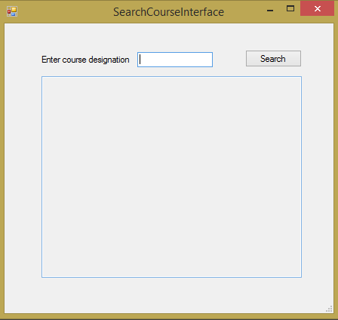

Various fields available on this form will be:

* *Course_Designation*: will display the course with the same course designation as entered by the student/faculty.

**ix. Register Course**

This form will be accessible to only the students. It will allow them to register for a course at the university.

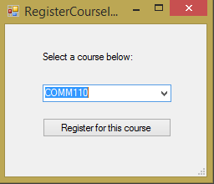

Various fields available on this form will be:

* *Course_Designation*: will display all the courses available for a student for their current semester of a particular program. Errors message will display if a courses is unavailable for registration (for a variety of reasons).

**x. Drop Course**

This form will be accessible to only the students. It will allow them to drop a course at the university.

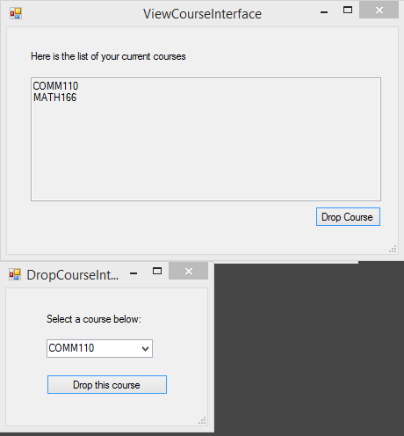

Various fields available on this form will be:

*Course_Designation*: will display all the courses a student is taking for their current semester of a particular program.

**xi. Generate Reports**

The reports will be accessible to the administrator. The system will generate text documents of different reports according to the specified criteria. The students will be able to generate their registration based on courses they have taken or are currently taking.

1. Generate Registration Report – Course Registration of a Student
2. All Students’ Course Information
3. Details of a Course
4. List All Courses

**3.1.2 Hardware Interfaces**

As stated in Section 2.1.3

**3.1.3 Software Interfaces**

As stated in Section 2.1.4

**3.1.4 Communication Interfaces**

None

**3.2. Functional Requirements**

**3.2.1. MAINTAIN MEMBER DETAILS**

|  |
| --- |
| **MAINTAIN MEMBER DETAILS**  **A. Use Case Description**  **Introduction**  This use case documents the steps that must be followed in order to maintain member details of a user. |
| **Actors**  Administrator  Data Entry Operator |
| **Pre-Conditions**  Administrator/Data Entry Operator must be logged into the URS system. |
| **Post-Conditions**  If the use case is successful, Member information is created, modified, or deleted, and the database is updated. Otherwise, the system state remains unchanged. |
| **Basic Flow**  This use case starts when the administrator/data entry operator wishes to create/modify/delete/view member information.  1. The system displays a row of buttons with actions that can handle member information (Create Member, Modify Member, Delete Member, and View Members).  2. Once the faculty presses the requisite button, one of the sub flows is executed.  • If the faculty selects “Create Member”, the **Create Member sub flow is executed**.  • If the faculty selects “Modify Member”, the **Modify Member sub flow is executed.**  • If the faculty selects “Delete Member”, the **Delete Member sub flow is executed.**  • If the faculty selects “View Member”, the **View Member sub flow is executed.**  **Basic Flow 1: Create Member**  1. The system prompts administrator/data entry operator to select “student” or “faculty” member creation.  2. The system reads in the information and displays blank form based on the selection  a. If “student” was selected, the form displays the following for the administrator/data entry operator to enter:   * + First Name   + Last Name   + Department ID   + Program ID   + Current Semester   + Email   + Date of Admission   + Phone Number   + Current Credit Hours   b. If “faculty” was selected, the form displays the following for the administrator/data entry operator to enter:   * + First Name   + Last Name   + Department ID   + Email   + Phone Number   **Basic Flow 2: Modify Member**  1. The system prompts for a member id.  2. The system retrieves and displays the member’s information.  3. The Administrator/Data Entry Operator makes the desired changes to the following Member information based on:  a. Student Members   * + First Name   + Last Name   + Department ID   + Program ID   + Current Semester   + Email   + Date of Admission   + Phone Number   + Current Credit Hours   b. Faculty Members   * + First Name   + Last Name   + Department ID   + Email   + Phone Number   4. Once the Administrator/Data Entry Operator completes their changes, the system updates the Member information with the new information given.  **Basic Flow 3: Delete Member**  1. The system prompts for and reads in a member id. 2. The system prompts the Administrator/Data Entry Operator to confirm the deletion of the member. 3. The Administrator/Data Entry Operator verifies the deletion.  4. The system deletes the member.  **Basic Flow 4: View Member**  1. The system prompts for and reads in a member id.  2. The Display Member function is called.  2. The system retrieves and displays the following information for the member in the system based on:  a. Student Members   * + First Name   + Last Name   + Department ID   + Program ID   + Current Semester   + Email   + Date of Admission   + Phone Number   + Current Credit Hours   b. Faculty Members   * + First Name   + Last Name   + Department ID   + Email   + Phone Number   **Alternative Flows**  **Alternative Flow 1: Invalid Entry**  If in the Create Member, Modify Member, Delete Member, or View Member flows, the Administrator/Data Entry Operator enters invalid First Name/Last Name/Department ID/Program ID/Current Semester/Email/Date of Admission/Phone Number/Current Credit Hours, depending on if the “student” or “faculty” member is being maintained, the system displays an appropriate error message. The Administrator/Data Entry Operator returns to the basic flow and may reenter the invalid entry.  **Alternative Flow 2: Modify cancelled**  If in the Modify Member flow, the administrator/data entry operator decides not to modify a member’s information, the action is cancelled and the Basic Flow is re-started at the beginning.  **Alternative Flow 3: Delete cancelled**  If in the Delete Member flow, the administrator/data entry operator decides not to delete a member, the deletion is cancelled and the Basic Flow is re-started at the beginning.  **Alternative Flow 4: User Exits**  This allows the administrator/data entry operator to exit at any time during the use case. The use case ends. |
| **Special Requirement**  None |
| **Associated use case**  Login  Display Member |
| **B. Validity Checks**  1. The member id will be an auto-generated id of only numbers.  2. The first and last name of a member can have a max length of 40 characters.  3. The email of a member has a max length of 80 characters.  4. The phone number of a member will be formatted like (***)***-****.  **C. Sequencing information**  None  **D. Error Handling/Response to Abnormal Situations**  If any of the validations flow does not hold true, an appropriate error message will be prompted to the user for correcting the abnormality. |

**3.2.2. MAINTAIN COURSE DETAILS**

|  |
| --- |
| **MAINTAIN COURSE DETAILS**  **A. Use Case Description**  **Introduction**  This use case documents the steps that must be followed in order to create, modify, delete, or view course details. |
| **Actors**  Admin­­istrator  Data Entry Operator |
| **Pre-Conditions**  Administrator/Data Entry Operator must be logged into the URS system. |
| **Post-Conditions**  If the use case is successful, a course is created, modified, or deleted, and the database is updated. Otherwise, the system state remains unchanged. |
| **Flow of Events Basic Flow**  This use case starts when the faculty wishes to create/modify/delete/view course information.  1. The system displays a list of the courses that the administrator/data entry operator is allowed to access, as well as buttons next to them displaying things that can be done to that course (Create Course, Modify Course, Delete Course, or View Course).  2. Once the administrator/data entry operator presses the requisite button, one of the sub flows is executed.  • If the faculty selects “Create a Course”, the **Create Course sub flow is executed**.  • If the faculty selects “Modify Course”, the **Modify Course sub flow is executed.**  • If the faculty selects “Delete Course”, the **Delete Course sub flow is executed.**  • If the faculty selects “View Course”, the **View Course sub flow is executed.**  **Basic Flow 1: Create Course**  1. The system displays a blank form for the administrator/data entry operator to enter the course information. This includes:   * Course Title * Course Designation * Instructor * Department * Credit Hour * Description * Prerequisite Course * Year/semester * Max Capacity * Location * Schedule   **Basic Flow 2: Modify Course**  1. The system prompts for a course id, then retrieves and displays the course information.  2. Upon clicking modify, the system displays more detailed information about that course  3. The administrator/data entry operator makes the desired changes to the course information to:   * Course Title * Course Designation * Instructor * Department * Credit Hour * Description * Prerequisite Course * Year/semester * Max Capacity * Location * Schedule   4. Once the administrator/data entry operator updates the necessary information, the system updates the course information with the new information.  **Basic Flow 3: Delete Course**  1. The system prompts for a course id and the particular year/semester, then retrieves and displays the course information. 2. The system prompts the administrator/data entry operator to confirm the deletion of the course. 3. The administrator/data entry operator verifies the deletion.  4. The system deletes the course.  **Basic Flow 4: View Course**  1. The Display Course function is called.  **Alternative Flows**  **Alternative Flow 1: Invalid Entry**  If, in the Create Course, Modify Course, Delete Course, the administrator/data entry operator enters invalid Course Title /Course Designation/Instructor/Department/Credit Hour/Description/Prerequisite Course or leaves the field empty, the system displays an appropriate error message. The administrator/data entry operator returns to the basic flow and may reenter the invalid entry.  **Alternative Flow 2: Modify cancelled**  If in the Modify Course flow, the administrator/data entry operator decides not to Modify the course, the modification is cancelled and the Basic Flow is re-started at the beginning.  **Alternative Flow 3: Delete cancelled**  If in the Delete Course flow, the faculty decides not to Delete the course, the deletion is cancelled and the Basic Flow is re-started at the beginning.  **Alternative Flow 4: User Exits**  This allows the user to exit at any time during the use case. The use case ends. |
| **Special Requirement**  None |
| **Associated use case**  Login |
| **B. Validity Checks**   1. Every course will have a unique Course Designation, consisting of characters and numbers. 2. Course Designation cannot be blank. 3. Instructor cannot be blank. 4. Course Title cannot be blank. a. The title will have a max length of 50 characters. 5. The course description can be between 0 and 255 characters in length, with spaces and punctuation as the only special characters allowed. 6. Department cannot be blank. 7. Department matches a department allowed. 8. Schedule cannot be blank. 9. Schedule must be in the format of MW 3:00-4:15, that is, day abbreviation (MTuWThFSaSu), then a time range. 10. Max Capacity cannot be blank. 11. Max Capacity must be a positive integer between 1 and 300. 12. A course id will be an auto-generated ID consisting of only numbers. 13. Only a course of the current year/semester can be modified.   **C. Sequencing information**  None  **D. Error Handling/Response to Abnormal Situations**  If any of the validations flow does not hold true, an appropriate error message will be  prompted to the user for correcting the abnormality. |

**3.2.3. MAINTAIN SEMESTER DETAILS**

|  |
| --- |
| **MAINTAIN SEMESTER DETAILS**  **A. Use Case Description**  **Introduction**  This use case documents the steps that must be followed in order to maintain semester details of a user. |
| **Actors**  Administrator |
| **Pre-Conditions**  Administrator must be logged into the URS system. |
| **Post-Conditions**  If the use case is successful, semester information is created, modified, or deleted, and the database is updated. Otherwise, the system state remains unchanged. |
| **Basic Flow**  This use case starts when the Administrator wishes to create/modify/delete/view semester information.  1. The system displays a row of buttons with actions that can handle semester information (Create Semester, Modify Semester, Delete Semester, and View Semesters).  2. Once the faculty presses the requisite button, one of the sub flows is executed.  • If the faculty selects “Create Semester”, the **Create Semester sub flow is executed**.  • If the faculty selects “Modify Semester”, the **Modify Semester sub flow is executed.**  • If the faculty selects “Delete Semester”, the **Delete Semester sub flow is executed.**  • If the faculty selects “View Semester”, the **View Semester sub flow is executed.**  **Basic Flow 1: Create Semester**  1. The system displays a blank form for the administrator to enter:   * Semester Number * Program * Total Credits   **Basic Flow 2: Modify Semester**  1. The system prompts for a semester id.  2. The system retrieves and displays the semester’s information.  3. The administrator makes the desired changes to the following Semester information:   * Semester Number * Program * Total Credits   4. Once the administrator completes their changes, the system updates the semester information with the new information given.  **Basic Flow 3: Delete Semester**  1. The system prompts for and reads in a semester id. 2. The system prompts the administrator to confirm the deletion of the semester. 3. The administrator verifies the deletion.  4. The system deletes the semester.  **Basic Flow 4: View Semester**  1. The system prompts for and reads in a semester id.  2. The system retrieves and displays the following information for the semester in the system:   * Semester ID * Semester Number * Program * Total Credits   **Alternative Flows**  **Alternative Flow 1: Invalid Entry**  If in the Create Semester, Modify Semester, Delete Semester, or View Semester flows, the administrator enters invalid Semester ID/Semester Number /Program/Total Credits the system displays an appropriate error message. The administrator returns to the basic flow and may reenter the invalid entry.  **Alternative Flow 2: Modify cancelled**  If in the Modify Semester flow, the administrator decides not to modify a semester’s information, the action is cancelled and the Basic Flow is re-started at the beginning.  **Alternative Flow 3: Delete cancelled**  If in the Delete Semester flow, the administrator decides not to delete a semester, the deletion is cancelled and the Basic Flow is re-started at the beginning.  **Alternative Flow 4: User Exits**  This allows the administrator to exit at any time during the use case. The use case ends. |
| **Special Requirement**  None |
| **Associated use case**  Login |
| **B. Validity Checks**  1. The semester id will be an auto-generated id of only numbers.  **C. Sequencing information**  None  **D. Error Handling/Response to Abnormal Situations**  If any of the validations flow does not hold true, an appropriate error message will be prompted to the user for correcting the abnormality. |

**3.2.4. MAINTAIN PROGRAM DETAILS**

|  |
| --- |
| **MAINTAIN PROGRAM DETAILS**  **A. Use Case Description**  **Introduction**  This use case documents the steps that must be followed in order to maintain program details of a user. |
| **Actors**  Administrator |
| **Pre-Conditions**  Administrator must be logged into the URS system. |
| **Post-Conditions**  If the use case is successful, program information is created, modified, or deleted, and the database is updated. Otherwise, the system state remains unchanged. |
| **Basic Flow**  This use case starts when the Administrator wishes to create/modify/delete/view Program information.  1. The system displays a row of buttons with actions that can handle Program information (Create Program, Modify Program, Delete Program, and View Programs).  2. Once the faculty presses the requisite button, one of the sub flows is executed.  • If the faculty selects “Create Program”, the **Create Program sub flow is executed**.  • If the faculty selects “Modify Program”, the **Modify Program sub flow is executed.**  • If the faculty selects “Delete Program”, the **Delete Program sub flow is executed.**  • If the faculty selects “View Program”, the **View Program sub flow is executed.**  **Basic Flow 1: Create Program**  1. The system displays a blank form for the administrator to enter:   * Program Title * Number of Semesters * Duration * Degree level * Department ID   **Basic Flow 2: Modify Program**  1. The system prompts for a program id.  2. The system retrieves and displays the program’s information.  3. The administrator makes the desired changes to the following program information:   * Program Title * Number of Semesters * Duration * Degree level * Department ID   4. Once the administrator completes their changes, the system updates the program information with the new information given.  **Basic Flow 3: Delete Program**  1. The system prompts for and reads in a program id. 2. The system prompts the administrator to confirm the deletion of the program. 3. The administrator verifies the deletion.  4. The system deletes the program.  **Basic Flow 4: View Program**  1. The system prompts for and reads in a program id.  2. The system retrieves and displays the following information for the program in the system:   * Program ID * Program Title * Number of Semesters * Duration * Degree level * Department ID   **Alternative Flows**  **Alternative Flow 1: Invalid Entry**  If in the Create Program, Modify Program, Delete Program, or View Program flows, the administrator enters invalid Program ID/Program Title/Number of Semesters/Duration/Degree Level/Department ID the system displays an appropriate error message. The administrator returns to the basic flow and may reenter the invalid entry.  **Alternative Flow 2: Modify cancelled**  If in the Modify Program flow, the administrator decides not to modify a program’s information, the action is cancelled and the Basic Flow is re-started at the beginning.  **Alternative Flow 3: Delete cancelled**  If in the Delete Program flow, the administrator decides not to Delete a program, the deletion is cancelled and the Basic Flow is re-started at the beginning.  **Alternative Flow 4: User Exits**  This allows the administrator to exit at any time during the use case. The use case ends. |
| **Special Requirement**  None |
| **Associated use case**  Login |
| **B. Validity Checks**  1. A program title may have a max length of 60 characters.  2. The program id will be an auto-generated id of only numbers.  3. The degree level will of a program may only be: BS, BA, or MS.  **C. Sequencing information**  None  **D. Error Handling/Response to Abnormal Situations**  If any of the validations flow does not hold true, an appropriate error message will be prompted to the user for correcting the abnormality. |

**3.2.5. MAINTAIN DEPARTMENT DETAILS**

|  |
| --- |
| **MAINTAIN DEPARTMENT DETAILS**  **A. Use Case Description**  **Introduction**  This use case documents the steps that must be followed in order to maintain department details of a user. |
| **Actors**  Administrator |
| **Pre-Conditions**  Administrator must be logged into the URS system. |
| **Post-Conditions**  If the use case is successful, department information is created, modified, or deleted, and the database is updated. Otherwise, the system state remains unchanged. |
| **Basic Flow**  This use case starts when the Administrator wishes to create/modify/delete/view department information.  1. The system displays a row of buttons with actions that can handle department information (Create Department, Modify Department, Delete Department, and View Departments).  2. Once the faculty presses the requisite button, one of the sub flows is executed.  • If the faculty selects “Create Department”, the **Create Department sub flow is executed**.  • If the faculty selects “Modify Department”, the **Modify Department sub flow is executed.**  • If the faculty selects “Delete Department”, the **Delete Department sub flow is executed.**  • If the faculty selects “View Departments”, the **View Department sub flow is executed.**  **Basic Flow 1: Create Department**  1. The system displays a blank form for the administrator to enter:   * Department Name   **Basic Flow 2: Modify Department**  1. The system prompts for a department id.  2. The system retrieves and displays the Department information.  3. The administrator makes the desired changes to the following Department information:   * Department Name   4. Once the administrator completes their changes, the system updates the  Department information with the new information.  **Basic Flow 3: Delete Department**  1. The system prompts for and reads in a department id. 2. The system prompts the administrator to confirm the deletion of the department. 3. The administrator verifies the deletion.  4. The system deletes the department.  **Basic Flow 4: View Department**  1. The system retrieves and displays the following information for all Departments in the system:   * Department ID * Department Name   **Alternative Flows**  **Alternative Flow 1: Invalid Entry**  If in the Create Department, Modify Department, Delete Department, or View Department flows, the administrator enters invalid department name the system displays an appropriate error message. The administrator returns to the basic flow and may reenter the invalid entry.  **Alternative Flow 2: Modify cancelled**  If in the Modify Department flow, the administrator decides not to Modify the department, the action is cancelled and the Basic Flow is re-started at the beginning.  **Alternative Flow 3: Delete cancelled**  If in the Delete Department flow, the administrator decides not to Delete the department, the deletion is cancelled and the Basic Flow is re-started at the beginning.  **Alternative Flow 4: User Exits**  This allows the administrator to exit at any time during the use case. The use case ends. |
| **Special Requirement**  None |
| **Associated use case**  Login |
| **B. Validity Checks**  1. A department name may have a max length of 60 characters.  2. The department id will be an auto-generated id of only numbers.  **C. Sequencing information**  None  **D. Error Handling/Response to Abnormal Situations**  If any of the validations flow does not hold true, an appropriate error message will be prompted to the user for correcting the abnormality. |

**3.2.6. MAINTAIN LOGIN DETAILS**

|  |
| --- |
| **MAINTAIN LOGIN DETAILS**  **A. Use Case Description**  **Introduction**  This use case documents the steps that must be followed in order to maintain login details of a user. |
| **Actors**  Administrator |
| **Pre-Conditions**  Administrator must be logged into the URS system. |
| **Post-Conditions**  If the use case is successful, login information is created, modified, or deleted, and the database is updated. Otherwise, the system state remains unchanged. |
| **Basic Flow**  This use case starts when the Administrator wishes to create/modify/delete/view login information.  1. The system displays a row of buttons with actions that can be taken on a user’s login information (Create Login, Modify Login, Delete Login, and View Login).  2. Once the faculty presses the requisite button, one of the sub flows is executed.  • If the faculty selects “Create Login”, the **Create Login sub flow is executed**.  • If the faculty selects “Modify Login”, the **Modify Login sub flow is executed.**  • If the faculty selects “Delete Login”, the **Delete Login sub flow is executed.**  • If the faculty selects “View a User Login”, the **View Login sub flow is executed.**  **Basic Flow 1: Create Login**  1. The system displays a blank form for the administrator to enter a user’s:   * Username * Password * Role   **Basic Flow 2: Modify Login**  1. The system prompts for and reads in a username.  2. The system retrieves and displays the login information.  3. The administrator makes the desired changes to the following login information:   * Username * Password * Role   4. Once the administrator completes their changes, the system updates the  login information with the new information.  **Basic Flow 3: Delete Login**  1. The system prompts for and reads in a username. 2. The system prompts the administrator to confirm the deletion of the login. 3. The administrator verifies the deletion.  4. The system deletes the login.  **Basic Flow 4: View Login**  1. The system prompts for and reads in a username.  2. The system retrieves and displays the login information.  **Alternative Flows**  **Alternative Flow 1: Invalid Entry**  If in the Create Login, Modify Login, Delete Login, or View Login flows, the administrator enters invalid username/password/role the system displays an appropriate error message. The administrator returns to the basic flow and may reenter the invalid entry.  **Alternative Flow 2: Modify cancelled**  If in the Modify Login flow, the administrator decides not to Modify the course, the action is cancelled and the Basic Flow is re-started at the beginning.  **Alternative Flow 3: Delete cancelled**  If in the Delete Login flow, the administrator decides not to Delete the course, the deletion is cancelled and the Basic Flow is re-started at the beginning.  **Alternative Flow 4: User Exits**  This allows the administrator to exit at any time during the use case. The use case ends. |
| **Special Requirement**  None |
| **Associated use case**  Login |
| **B. Validity Checks**  1. A username must be a unique combination of characters and numbers.  2. A username must be between 3 and 20 characters in length.  3. A password can be a combination of characters and numbers.  4. A password must be between 5 and 50 characters in length.  5. A role can only be: faculty, administrator, student, or data entry operator.  **C. Sequencing information**  None  **D. Error Handling/Response to Abnormal Situations**  If any of the validations flow does not hold true, an appropriate error message will be prompted to the user for correcting the abnormality. |

**3.2.7. LOGIN**

|  |
| --- |
| **LOGIN**  **A. Use Case Description**  **Introduction**  This use case documents the steps that must be followed in order for a user to log in the system. |
| **Actors**  Student  Faculty  Administrator  Data Entry Operator |
| **Pre-Conditions**  The system must be initialized before the use case begins. |
| **Post-Conditions**  If the use case is successful, the student/faculty/administrator/data entry operator is logged onto the system else, the system state remains unchanged. |
| **Flow of Events**  **Basic Flow:**  1. The student/faculty/administrator/data entry operator enters username and password through the login screen.  2. The system validates the username and password.  3. The system logs in the student/faculty/administrator/data entry operator.  4. The system displays the student/faculty/administrator/data entry operator ‘s home screen, and allows certain actions based on each type of users.  **Alternative Flows**  **Alternative Flow 1: Unauthorized student/faculty/administrator**  If the system cannot validate the student/faculty/administrator/data entry operator username and password (due to not found in database or any other reason), then an error message is flagged and the use case returns to the beginning of the basic flow.  **Alternative Flow 2: User exits**  This allows the student/faculty/administrator/data entry operator to exit at any time during the use case. The use case ends. |
| **Special Requirement**  None |
| **Associated Use Case**  None |
| **B. Validity Checks**   1. The username will be between 3 and 20 characters. No spaces or special characters are allowed 2. The username cannot be blank. 3. The password will be between 5 to 50 characters. Any characters are allowed. 4. The password cannot be blank. 5. The password will be displayed as asterisks (*)   **C. Sequencing information**  None  **D. Error Handling/Response to Abnormal Situations**  If any of the validations flow does not hold true, an appropriate error message will be prompted to the user for correcting the abnormality. |

**3.2.8. SEARCH FOR A COURSE**

|  |
| --- |
| **SEARCH COURSE**  **A. Use Case Description**  **Introduction**  This use case documents the steps that must be followed in order for a user to search for a class in the system. |
| **Actors**  Student  Faculty |
| **Pre-Conditions**  The student/faculty must be logged into the URS system. |
| **Post-Conditions**  Upon a successful search, a list of classes that are relevant to the class search should be presented in a list format to the user. Each class should give a brief description and can be selected to view in greater detail. |
| **Flow of Events**  **Basic Flow:**  This use case starts when the student/faculty wishes to search for a course at the university.  1. The system takes the student/faculty to the course search page. The student/faculty is able to search for a course by:   * Course Designation   2. Display Course Function is called.  **Alternative Flows**  **Alternative Flow 1: User Exits**  This allows the user to exit at any time during this use case. This ends the use case.  **Alternative Flow 2: No Result**  When no course matches the course designation entered by the faculty/student, an error message will be displayed. |
| **Special Requirement**  None |
| **Associated Use Case**  Login |
| **B. Validity Checks**  1. The search will only return courses for the current semester.  **C. Sequencing Information**  None  **D. Error Handling/Response to Abnormal Situations**  If none of the alternative flows do not hold true, and one or more of the validations do not hold true, the an error message will be displayed informing the user to try again. |

**3.2.9. REGISTER FOR A COURSE**

|  |
| --- |
| **REGISTER FOR A COURSE**  **A. Use Case Description**  **Introduction**  This use case documents the steps that must be followed in order for a user to register for a course in the system. |
| **Actors**  Student |
| **Pre-Conditions**  The user must be logged into the URS system. |
| **Post-Conditions**  Upon a successful registration, the course should be added to the user's schedule, and the database is updated. |
| **Flow of Events**  **Basic Flow:**  This flow begins when the students wishes to register for a course.  1. The user will select the course that they want to register for.  2. The user will select the “Register” option in the course details  3. The system will check the user schedule for a conflict  4. The system will add the course to the user schedule  5. The system will inform the user that the he/she successfully registered  6. The system will return the course menu.  **Alternative Flows**  **Alternative Flow 1: User Exits**  This allows the user to exit at any time during this use case. This ends the use case.  **Alternative Flow 2: Unmet Prerequisite Course**  If a student selects a course that has an unmet prerequisite, the system will display an error message, then the student is returned to the basic flow. |
| **Special Requirement**  None |
| **Associated Use Case**  Login |
| **B. Validity Checks**   1. The system cannot overwrite another course 2. The system will not add a student to a course if no slots are available 3. A student cannot take more credit hours than allowed for a particular semester of a particular course.   **C. Sequencing Information**  None  **D. Error Handling/Response to Abnormal Situations**  If none of the alternative flows do not hold true, and one or more of the validations do not hold true, the an error message will be displayed informing the user to try again. |

**3.2.10. DROP A COURSE**

|  |
| --- |
| **DROP COURSE DETAILS**  **A. Use Case Description**  **Introduction**  This use case documents the steps that the student must follow in order to withdraw or drop a course. |
| **Actors**  Student |
| **Pre-Conditions**  The student must be logged into the URS system. |
| **Post-Conditions**  If the use case is successful, the student will drop from the course and the student’s record will be updated to reflect the change. Otherwise, the system remains unchanged. |
| **Flow of Events**  **Basic Flow:**  This use case starts when the student wishes to drop a course they is currently taking.   1. The system requests that the student select which courses they would like to drop. 2. The system prompts the student to confirm drop for selected course. 3. The student verifies the drop. 4. The system updates student course information   **Alternative Flows**  **Alternative Flow 1: Drop course not allowed**  If in the Drop Course flow, the set date for dropping a course has passed, the system displays an error message. The Basic Flow is re-started at the beginning.  **Alternative Flow 2: Drop cancelled**  If in the Drop Course flow, the student decides not to drop a course, the drop is cancelled and the Basic Flow is re-started at the beginning.  **Alternative Flow 3: User exits**  This allows the user to exit at any time during the use case. The use case ends. |
| **Special Requirement**  None |
| **Associated Use Case**  Login |
| **B. Validity Checks**   1. Classes listed to the student must be classes the student is taking for the current semester.   **C. Sequencing Information**  None  **D. Error Handling/ Response to Abnormal Situations**  If any of the validation flow does not hold true, an appropriate error message will be prompted to the user for correcting the abnormality |

**3.2.11. DISPLAY COURSE**

|  |
| --- |
| **DISPLAY COURSE**  **A. Use Case Description**  **Introduction**  This use case documents the steps that must be followed in order to view the details of a course. |
| **Actors**  Administrator  Data Entry OperatorStudent  Faculty |
| **Pre-Conditions**  Administrator/Data Entry Operator/Faculty/Student must be logged in. Faculty/Student must be using the Search Course function and then decide to examine a course.  Administrator/Data Entry Operator must be using the Maintain Course Details function and then decide to view a course. |
| **Post-Conditions**  Faculty/Student returns to Search for Courses use case.  Administrator/Data Entry Operator returns to Maintain Course Details use case. |
| **Flow of Events Basic Flow**  This use case starts when the faculty/student clicks on a course while using the Search for Courses feature or when the administrator/data entry operator clicks ‘view course’ in the Maintain Course Details function.  1. The system displays information about the course. 2. Then it returns to the Search Course use case for faculty/student or returns to Maintain Course Details for administrator/data entry operator.  **Alternative Flow 1: User Exits**  This allows the user to exit at any time during the use case. The use case ends. |
| **Special Requirement**  None |
| **Associated use case**  Login  Search Course  Maintain Course Details |
| **B. Validity Checks**   1. Checks to make sure the course being display has all pertinent information.   **C. Sequencing information**  None  **D. Error Handling/Response to Abnormal Situations**  If any of the validations flow does not hold true, an appropriate error message will be prompted to the user for correcting the abnormality. |

**3.2.12. DISPLAY MEMBER**

|  |
| --- |
| **DISPLAY MEMBER**  **A. Use Case Description**  **Introduction**  This use case documents the steps that must be followed in order to view the details of a member. |
| **Actors**  Administrator  Data Entry OperatorStudent  Faculty |
| **Pre-Conditions**  Administrator/Data Entry Operator/Faculty/Student must be logged in.  Administrator/Data Entry Operator must be using the Maintain Member Details function and then decide to view a member. |
| **Post-Conditions**  Administrator/Data Entry Operator returns to Maintain Member Details use case. |
| **Flow of Events Basic Flow**  This use case starts when the faculty/student decides to view their member information or when the administrator/data entry operator clicks ‘view member in the Maintain Member Details function.  1. The system displays information about the member based on “student” or “faculty” status of a member.  a. Student Members will view:   * + First Name   + Last Name   + Department ID   + Program ID   + Current Semester   + Email   + Date of Admission   + Phone Number   + Current Credit Hours   b. Faculty Members will view:   * + First Name   + Last Name   + Department ID   + Email   + Phone Number   2. Then it the use case ends for faculty/students or returns to Maintain Member Details use case for administrator/data entry operator.  **Alternative Flow 1: User Exits**  This allows the administrator/data entry operator/faculty/student to exit at any time during the use case. The use case ends. |
| **Special Requirement**  None |
| **Associated use case**  Login  Maintain Member Details |
| **B. Validity Checks**  1. Checks to make sure all information is being display based on “student” or “faculty” status.  **C. Sequencing information**  None  **D. Error Handling/Response to Abnormal Situations**  If any of the validations flow does not hold true, an appropriate error message will be prompted to the user for correcting the abnormality. |

**3.2.13. GENERATE REPORT**

|  |
| --- |
| **GENERATE REPORT DETAILS**  **A. Introduction**  This use case documents the steps that must be followed in order to generate reports in the URS. |
| **Actors**  Administrator |
| **Pre-Conditions**  Administrator must be logged into the URS system. |
| **Post-Conditions**  If the use case is successful, a report is generated based on the choice of the administrator. Otherwise, the system state remains unchanged. |
| **Flow of Events**  **Basic Flow**  This use case starts when the administrator wishes to generate a report.  1. The system requests that the administrator specify the type of report they would like to generate.  2. Once the administrator provides the requested information, a subflow is executed.   * If the administrator selects “Course Registration of a Student”, the **Course Registration of a Student subflow is executed.** * If the administrator selects “Details of a Course”, the **Details of a Course subflow is executed.** * If the administrator selects “All Students’ Course Information”, the **All Students’ Course Information subflow is executed.** * If the administrator selects “List All Courses”, the **List All Courses subflow is executed**.   **Basic Flow 1: Course Registration of a Student**  1. The Generate Registration Report function is called.  **Basic Flow 2: Details of a Course**  1. The system requests that the administrator enter the course designation.  2. Once the administrator provides the requested information, the system displays the course details, including:   * + Course Designation   + Course Title   + Instructor   + Course Description   + Department   + Location   + Schedule   + Max Capacity   + Student Enrolled   **Basic Flow 3: All Students’ Course Information**  1. The system displays a list of student details, including:   * Students’ name * Courses that each student registered for in the current semester.   **Basic Flow 4: List All Courses**  1. The system displays the list of courses, including:   * + Course Title   + Year/semester   + Course Designation   + Instructor   + Max Capacity   + Students Enrolled   **Alternative Flows:**  **Alternative Flow 1: Invalid entry**  If, in Details of a Course flow, the administrator enters invalid student id/course id, the system displays an appropriate message. The administrator returns to the basic flow and may reenter the invalid entry.  **Alternative Flow 2: Student/Course not found**  If, in the Course Registration of a Studentor the Details of a Course flow, the student or course with the specified student id/course id does not exists, the system displays an error message. The administrator returns to the basic flow and may reenter the student id/course id.  **Alternative Flow 3: User Exits**  This allows the user to exit at any time during the use case. The use case ends. |
| **Special Requirement**  None |
| **Associated use case**  Login  Generate Registration Report |
| **B. Validity Checks**   1. Only the administrator will be authorized to access the Generate Report Module. 2. The student id must be all numerical. 3. The student id and course designation cannot be blank. 4. The course designation must be unique to each course.   **C. Sequencing information**  None  **D. Error Handling/Response to Abnormal Situations**  If any of the validations flow does not hold true, an appropriate error message will be prompted to the user for correcting the abnormality. |

**3.2.14. GENERATE REGISTRATION REPORT**

|  |
| --- |
| **GENERATE REPORT REGISTRATION**  **A. Use Case Description**  **Introduction**  This use case documents the steps that must be followed in order to generate a registration report of student |
| **Actors**  AdministratorStudent |
| **Pre-Conditions**  Administrator/Student must be logged in.  Administrator be using the Generate Report function and then decide to view a student’s registration for a particular year/semester. |
| **Post-Conditions**  Administrator returns to Generate Report use case. |
| **Flow of Events Basic Flow**  This use case starts when the faculty/student decides to view their member information or when the administrator clicks ‘Course Registration of a Student’ in the Generate Report function.  1. The system prompts for a student username and year/semester for an administrator and just the year/semester for a student.  2. The system displays all courses taken by that student for a particular year/semester. The following information will be display   * Student ID * Student First Name * Student Last Name * Year/Semester * Course Designation * Course Title   3. Then it the use case ends for the student or returns to Generate Report use case for administrator/data entry operator.  **Alternative Flow 1: User Exits**  This allows the administrator/student to exit at any time during the use case. The use case ends. |
| **Special Requirement**  None |
| **Associated use case**  Login  Generate Report |
| **B. Validity Checks**  1. Checks to make sure proper information is being display based for a particular student for a particular year/semester.  **C. Sequencing information**  None  **D. Error Handling/Response to Abnormal Situations**  If any of the validations flow does not hold true, an appropriate error message will be prompted to the user for correcting the abnormality. |

**3.3. Performance Requirements**

1. Should run on 1Ghz, 512MB RAM machine.

2. Responses should be within 2 seconds

**3.4. Design Constraints**

None

**3.5. Software System Attributes**

**Usability**

The application will be user friendly, easy to operate, and the functions will be easy to understand.

**Reliability**

The application will be available to students throughout the registration period and have a high degree of fault tolerance.

**Security**

The application will be password protected. Users will have to enter the correct username and password to access the application.

**Maintainability**

The application will be designed in a maintainable manner. It will be easy to incorporate new requirements in the individual modules.

**Portability**

The application will be easily portable on any windows-based system that has Microsoft Visual Studios installed.

**3.6. Logical Database Requirements**

The following information will be placed in a database:

|  |  |
| --- | --- |
| **Table Name** | **Description** |
| Course | Records the details of courses at the university. |
| Login | Records the details of login information at the university. |
| Student | Records student details. |
| Faculty | Records faculty details. |
| Department | Records department details |
| Program | Records faculty details. |
| Semester | Records semester details. |
| Course_Semester | Records when courses are offered during a particular semester. |
| Course_Details | Records details of courses on a semester basis (like capacity, student enrollment). |
| Registration | Records registration of courses by students. |

**3.7. Other Requirements**

None

**UML Diagrams**

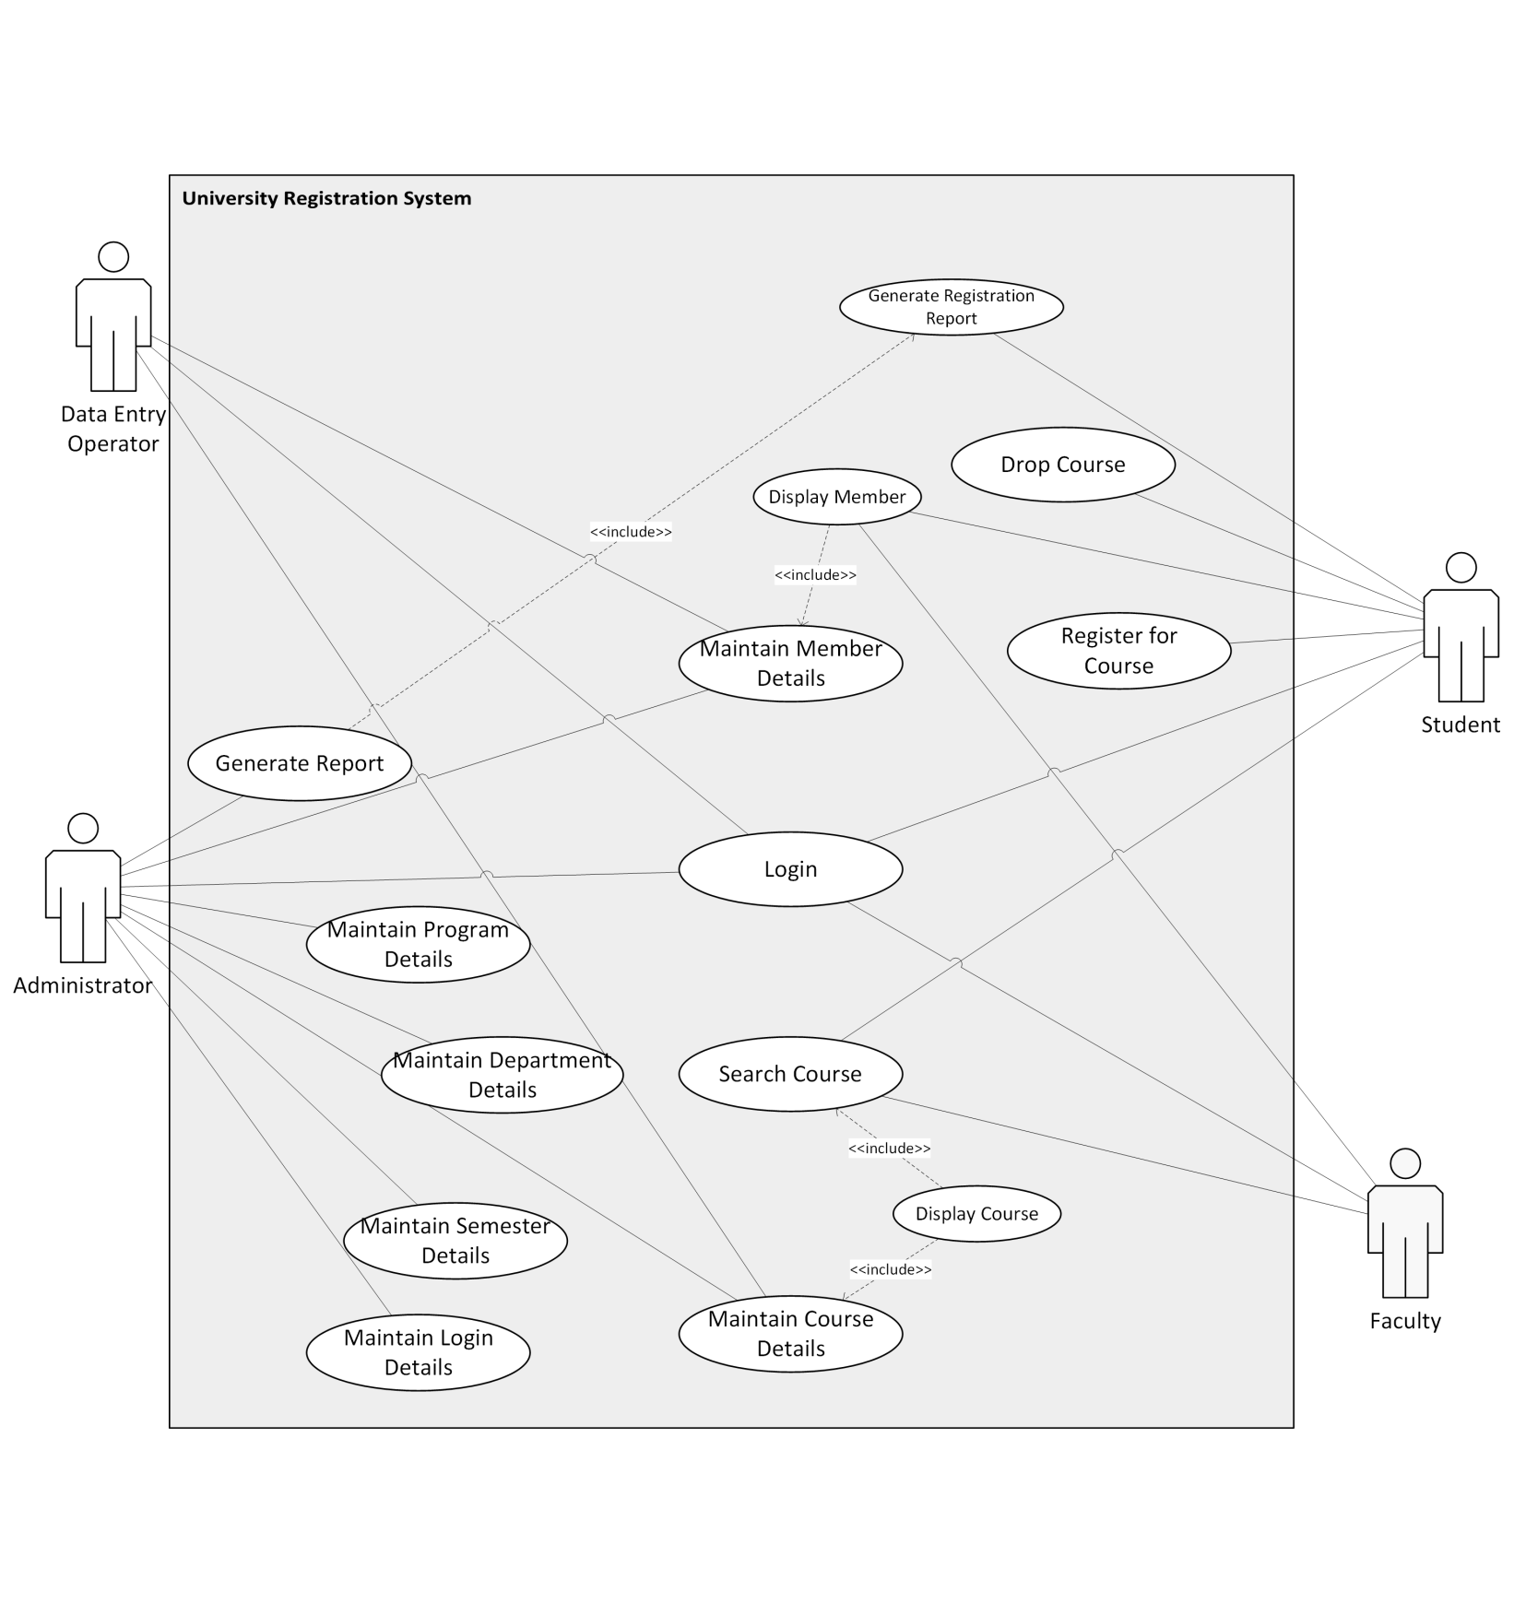**Use Case Diagram**

**Sequence Diagrams**

The sequence diagram for each function will be displayed in the following order:

1. Maintain Member Details
2. Maintain Course Details
3. Maintain Semester Details
4. Maintain Program Details
5. Maintain Department Details
6. Maintain Login Details
7. Login
8. Search for a Course
9. Register for a Course
10. Withdraw/Drop a course
11. Display Course
12. Display Member
13. Generate Report
14. Generate Registration Report/Card (Student)

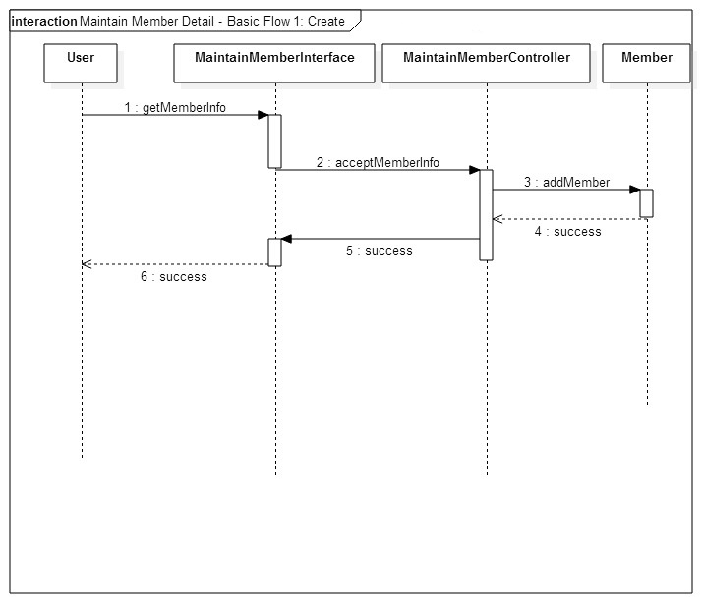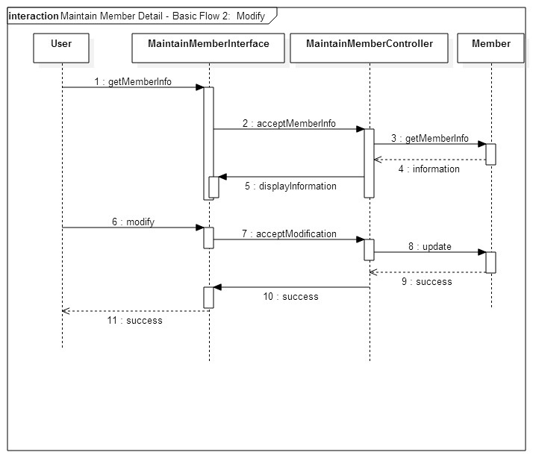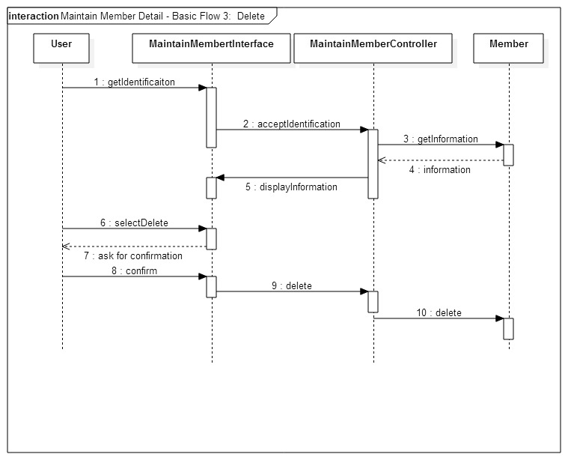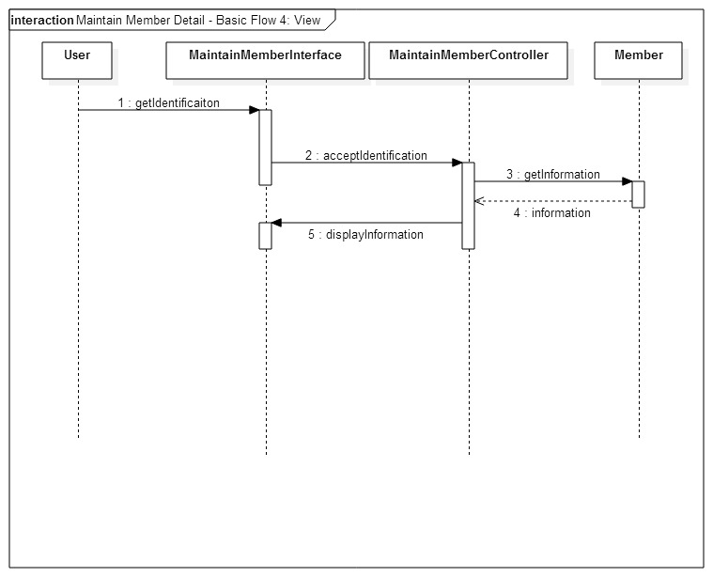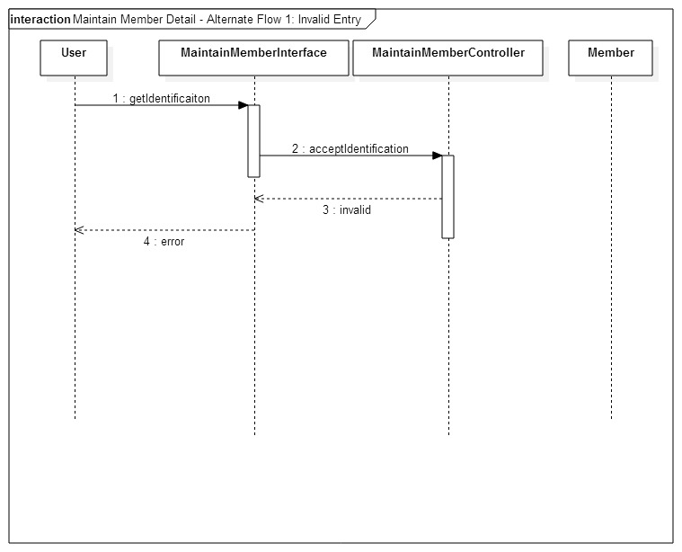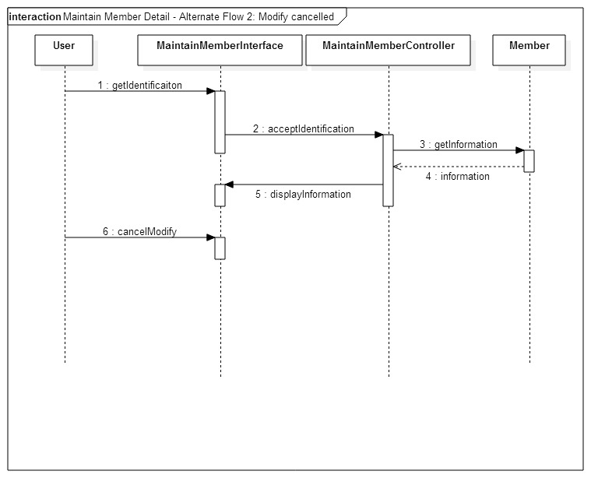

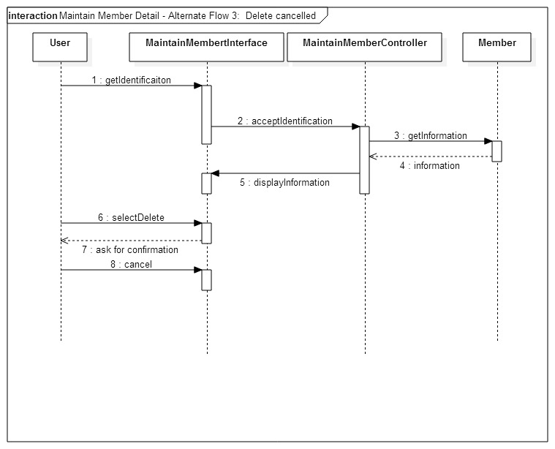

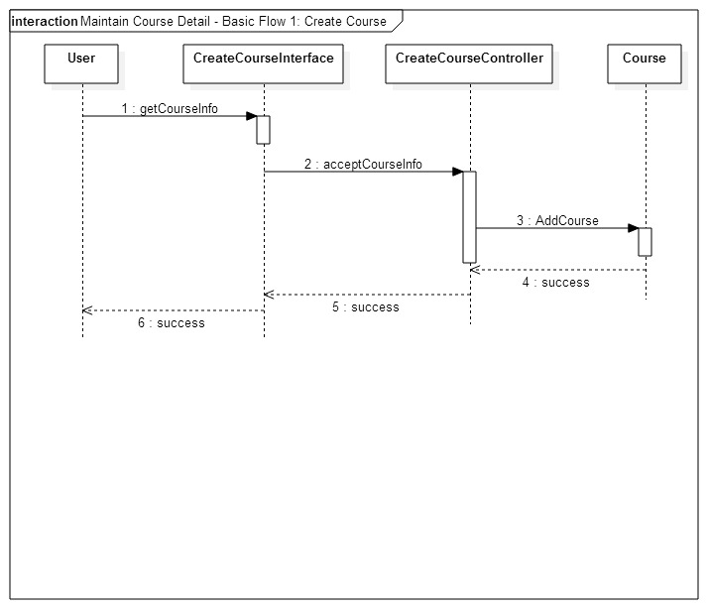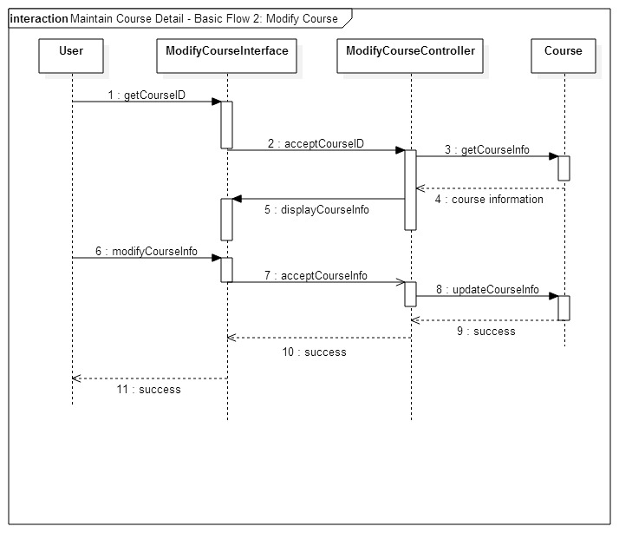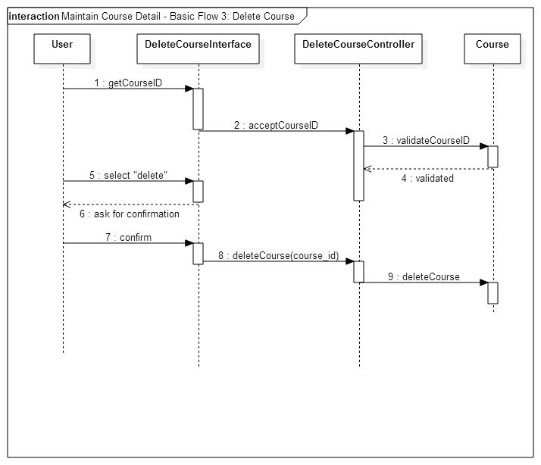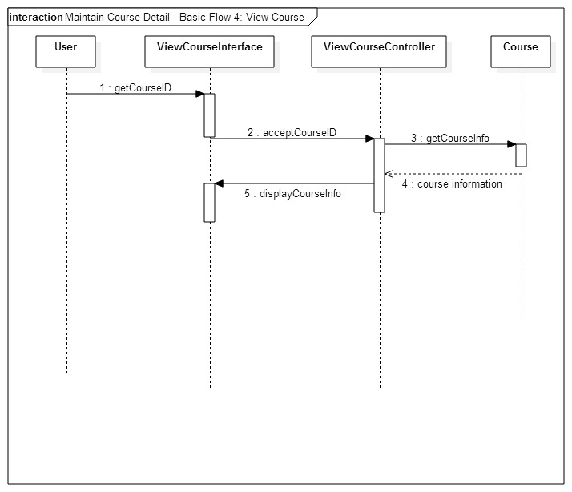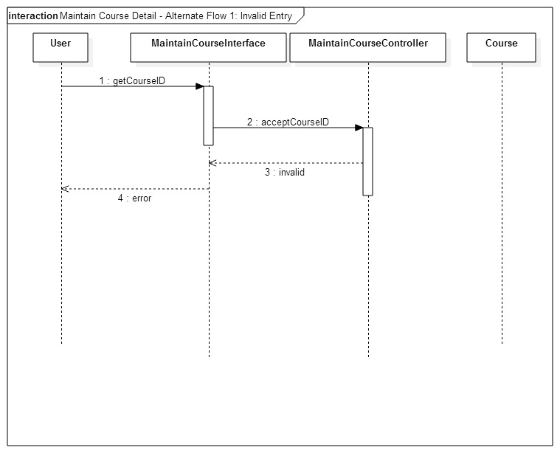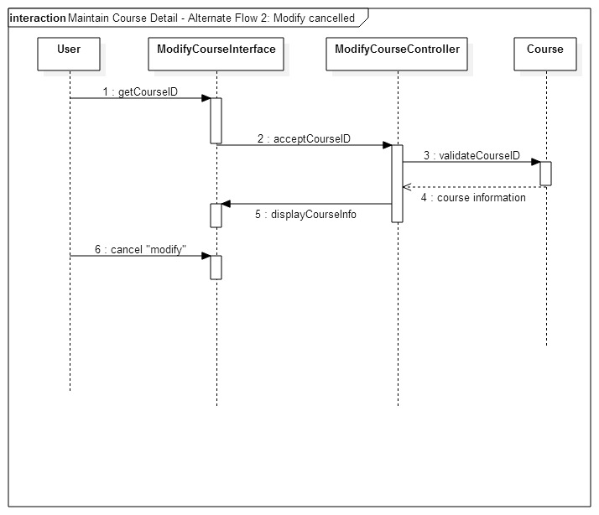

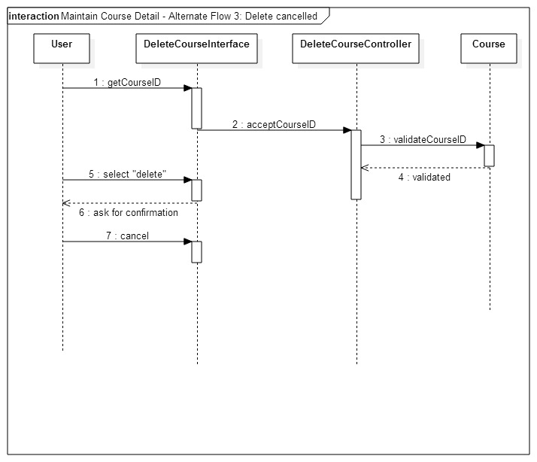

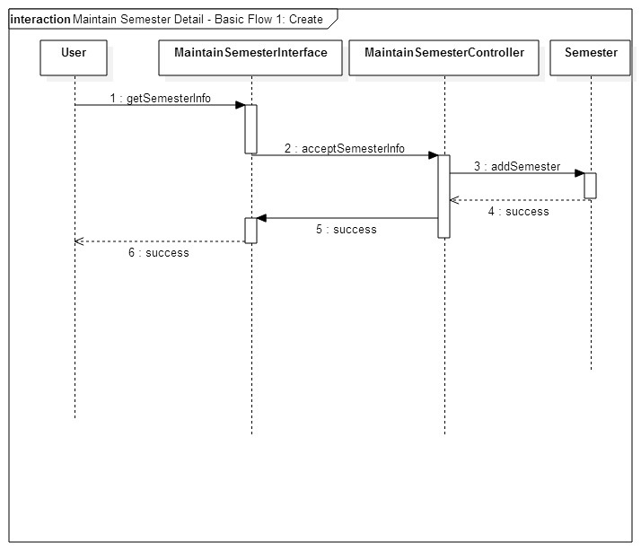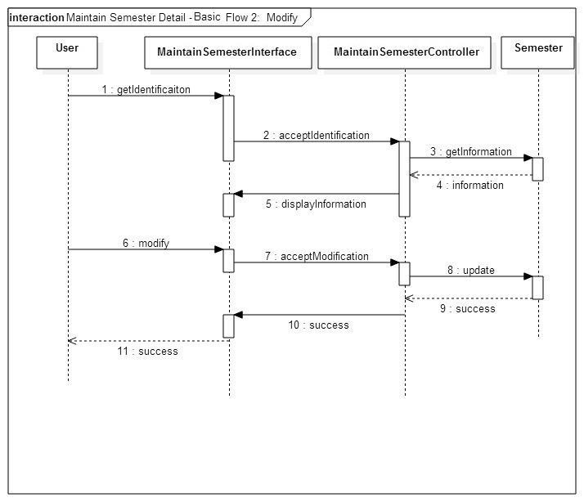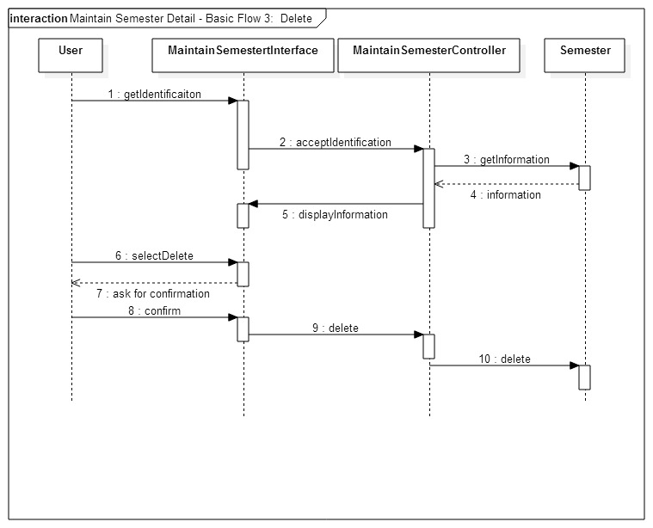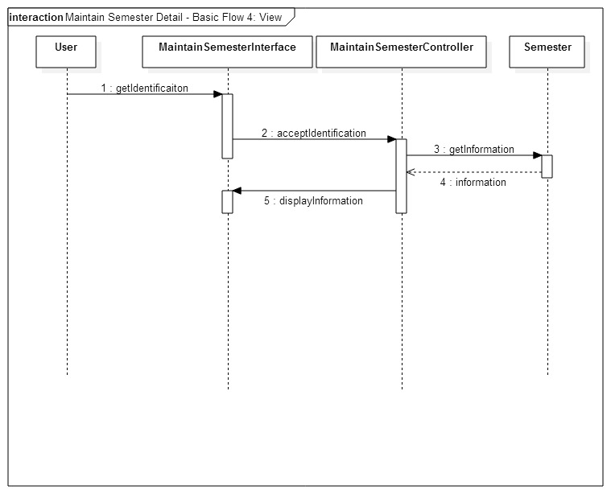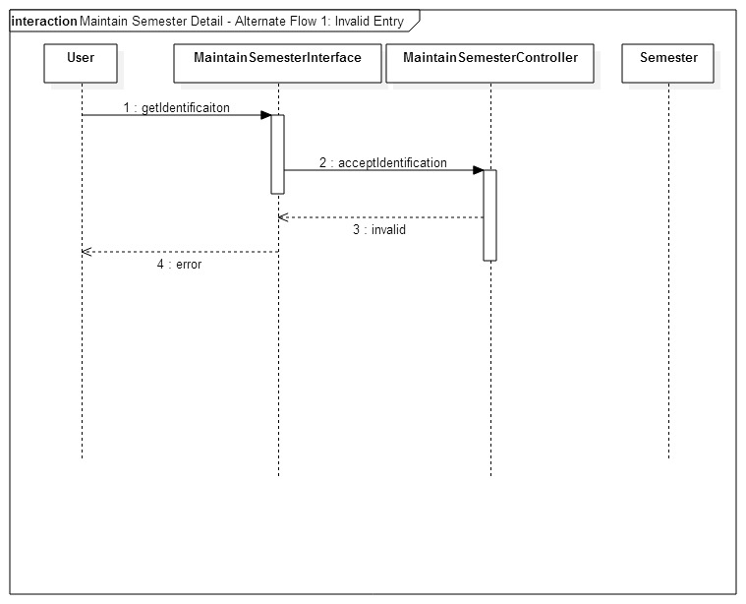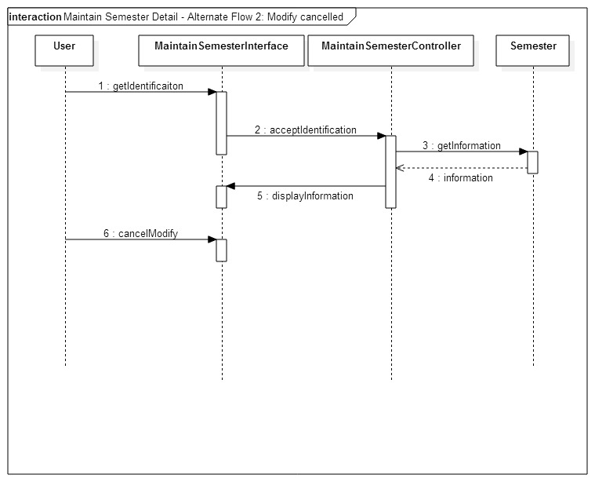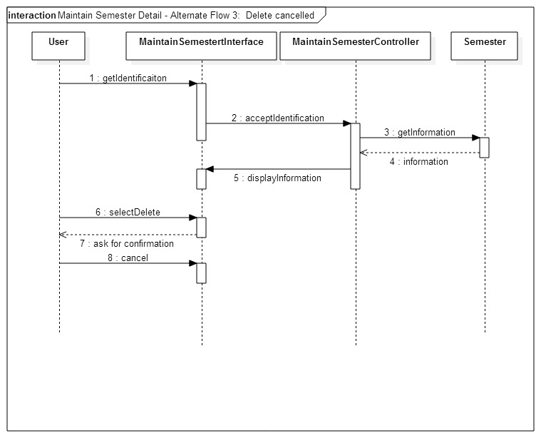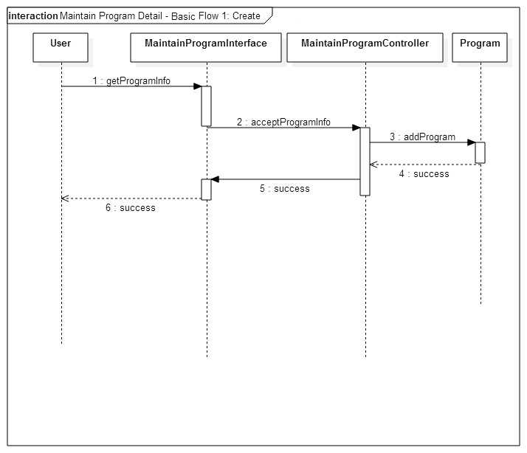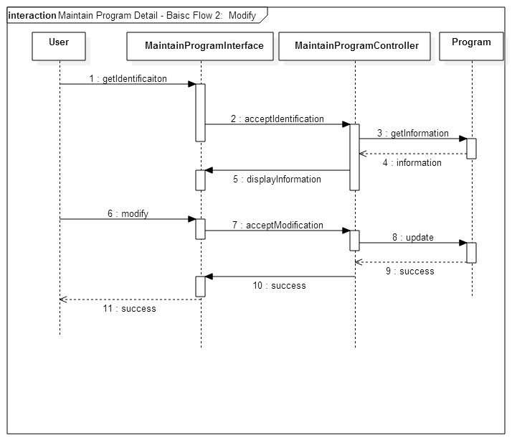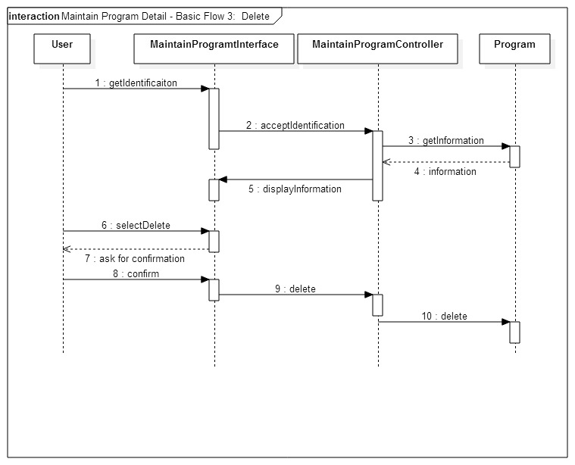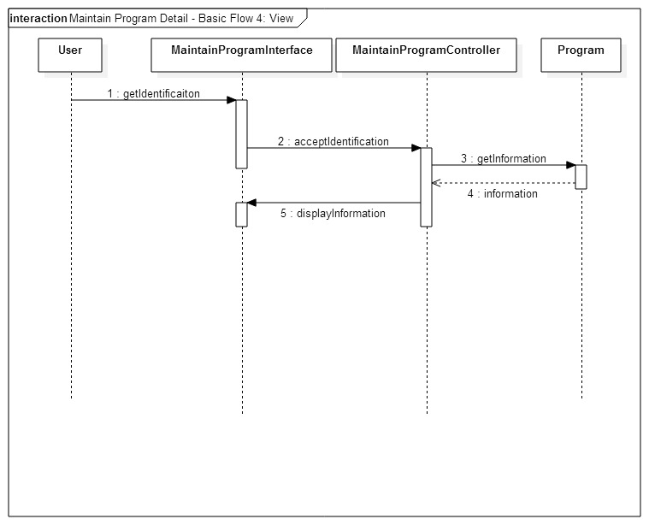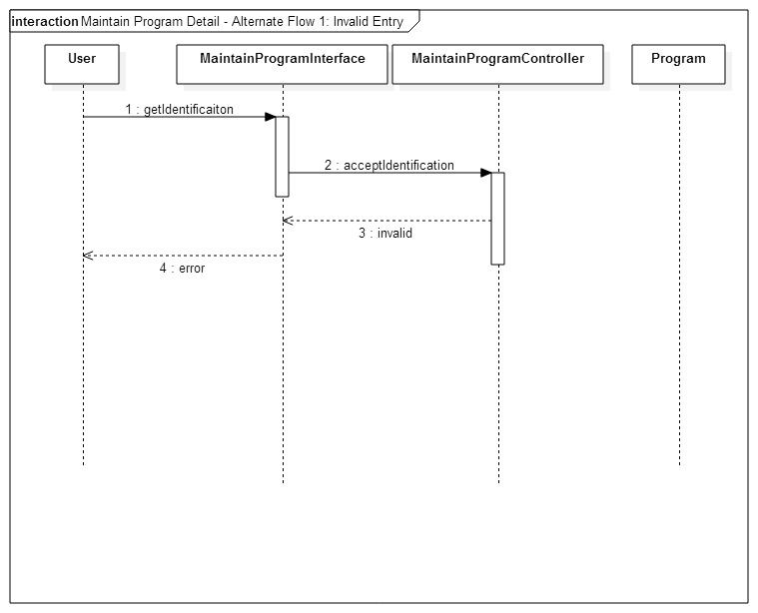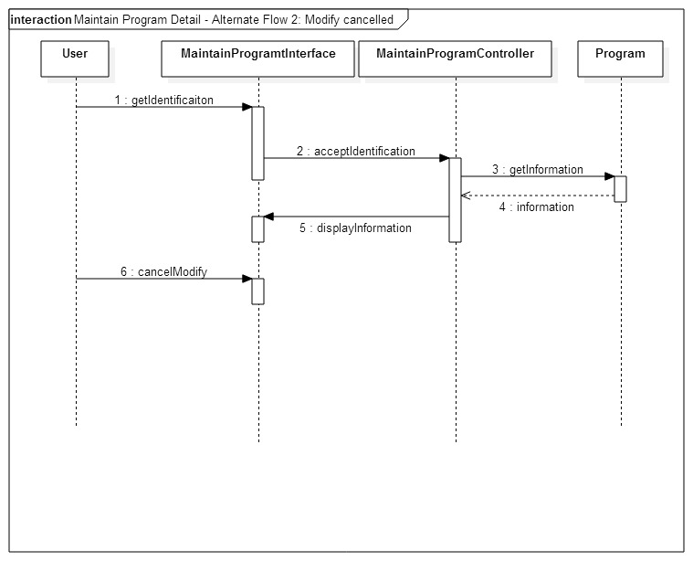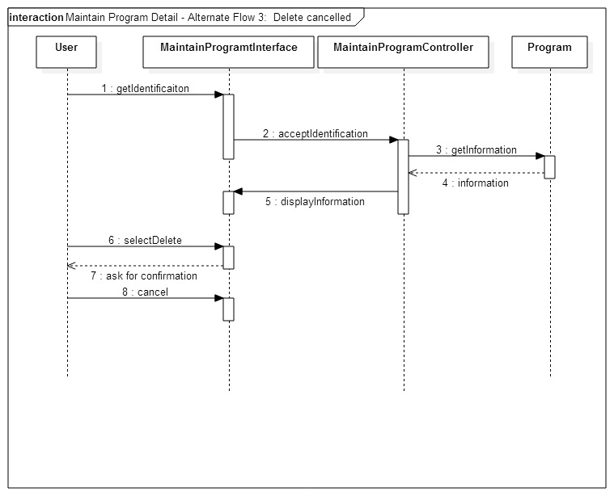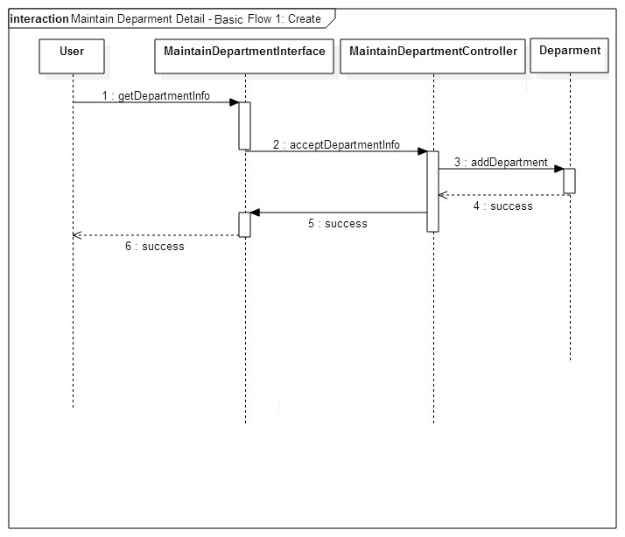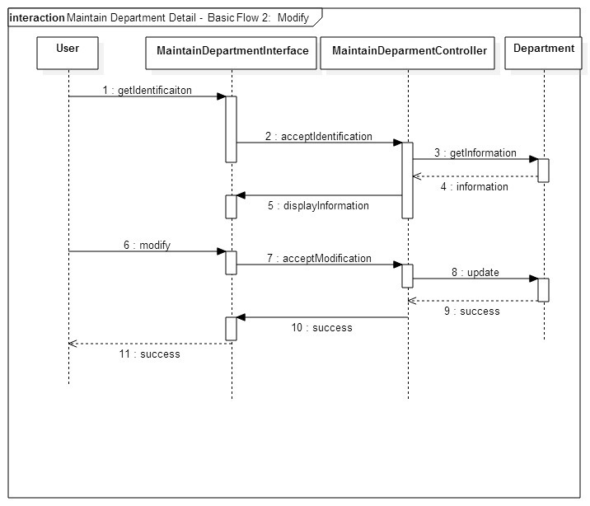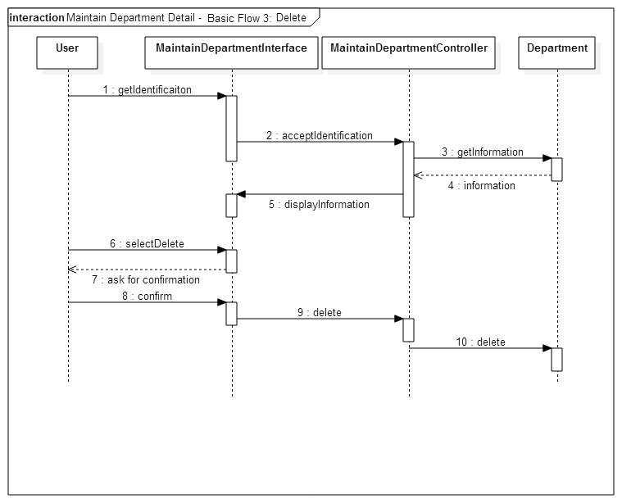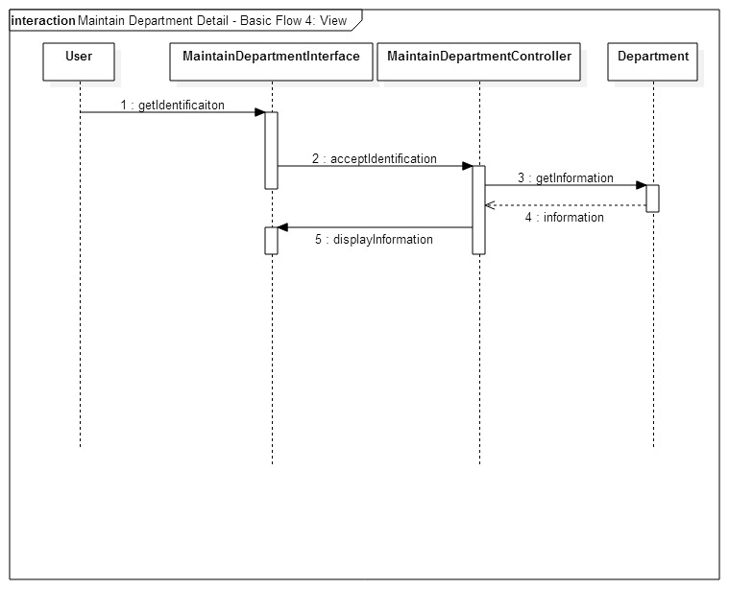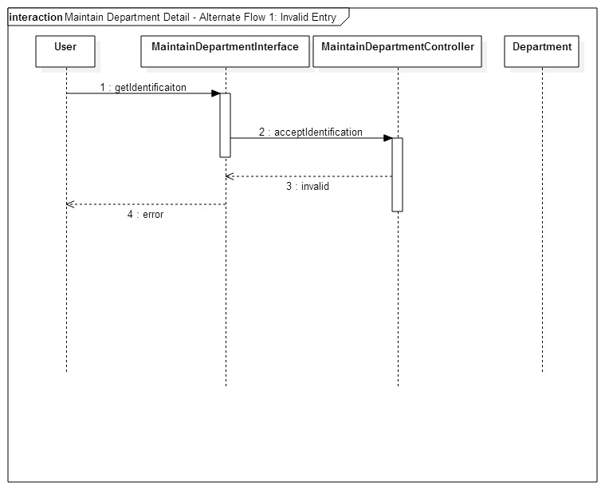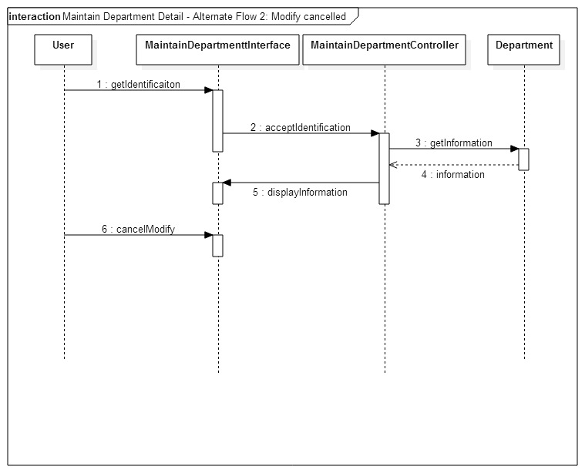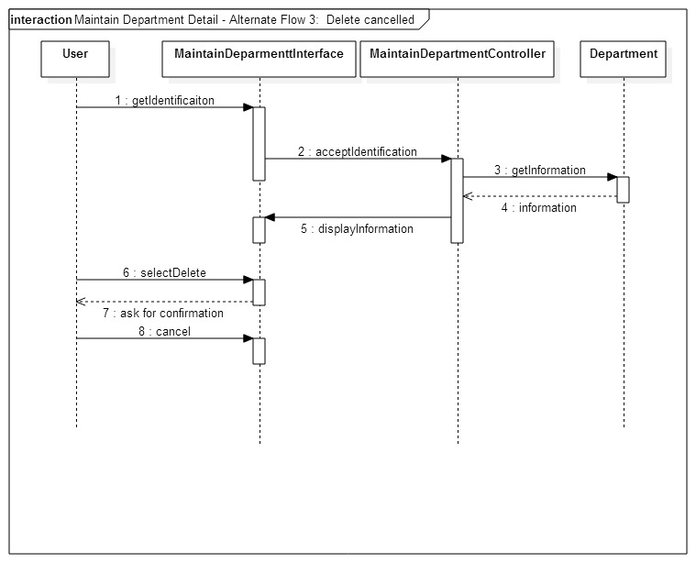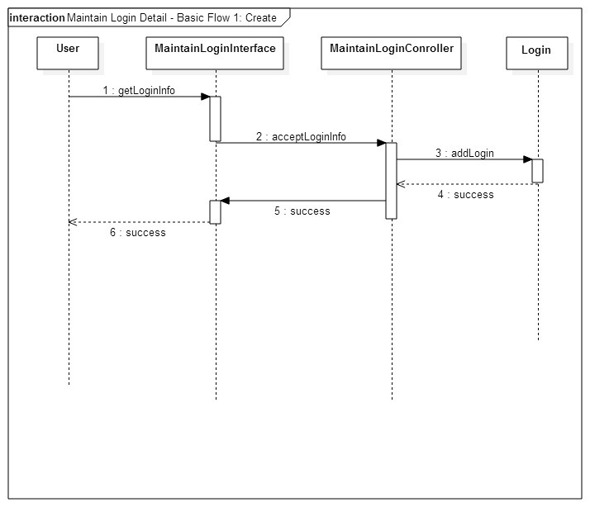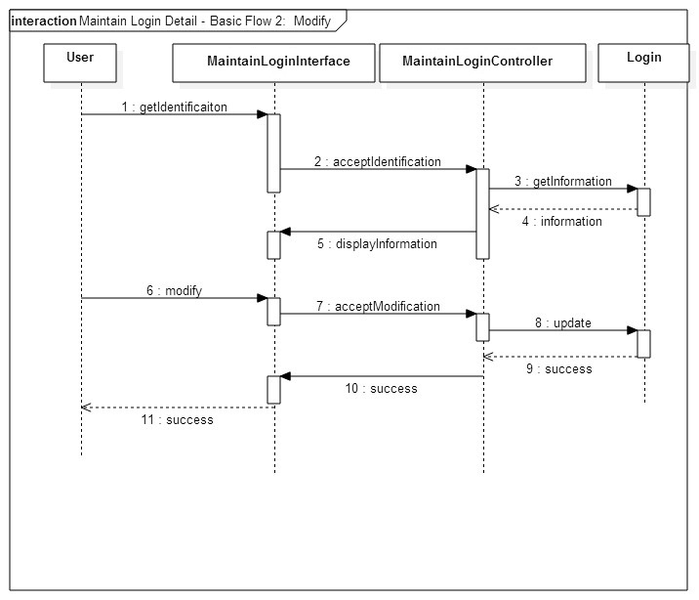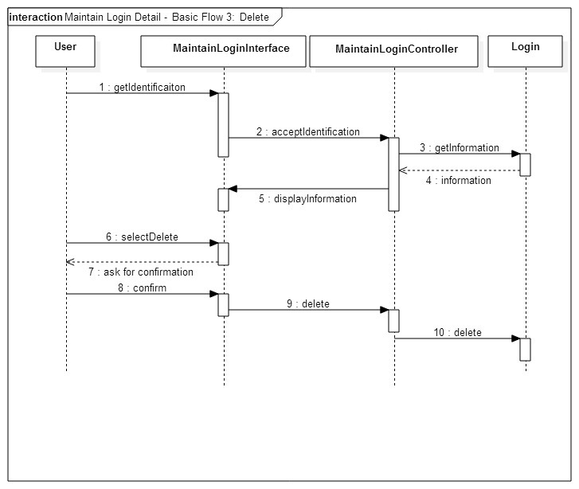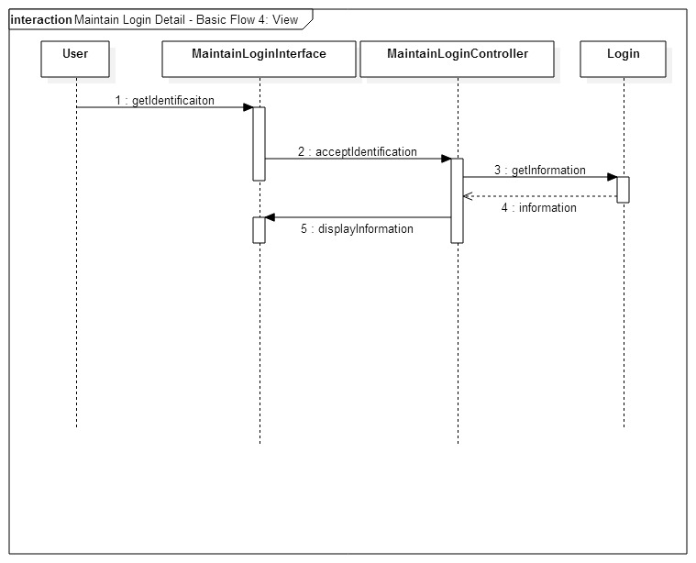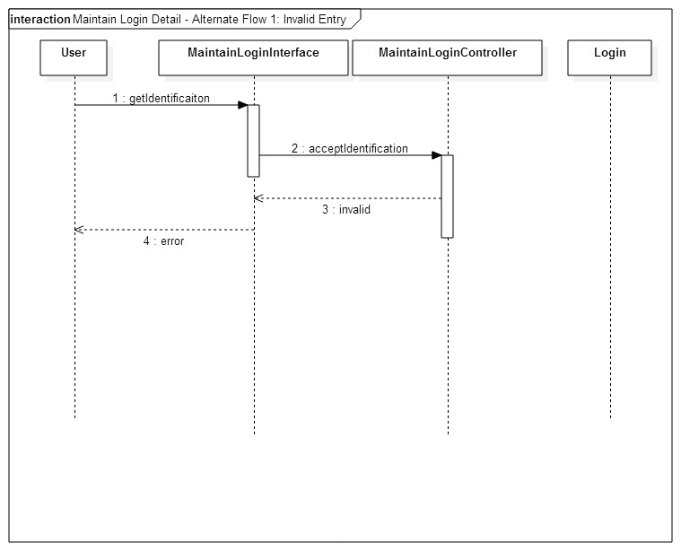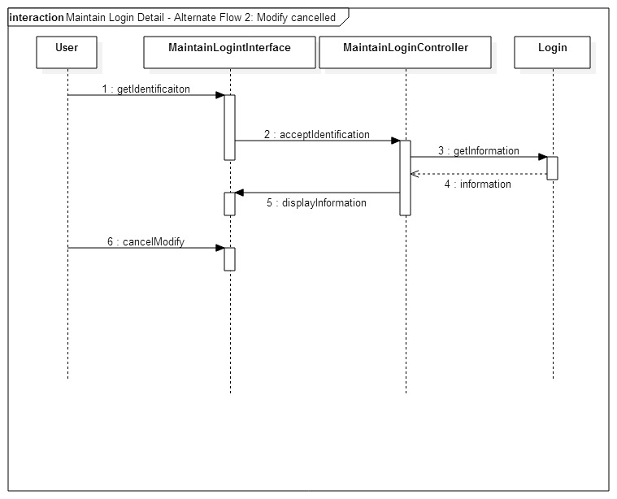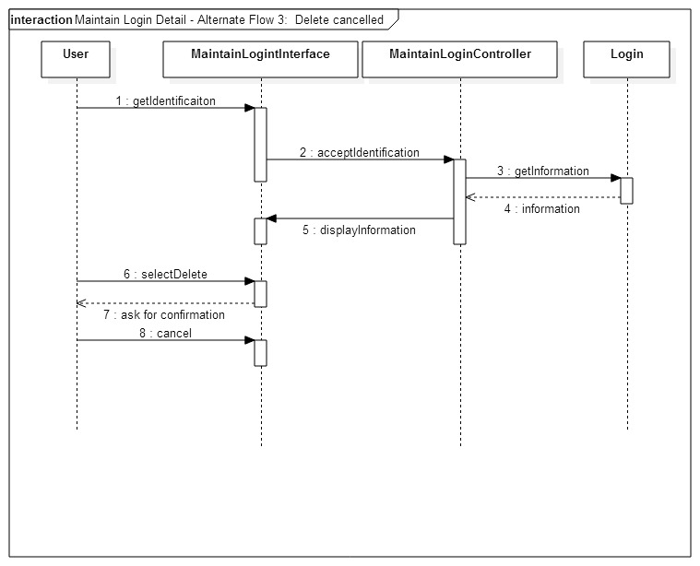

Login: Basic Flow

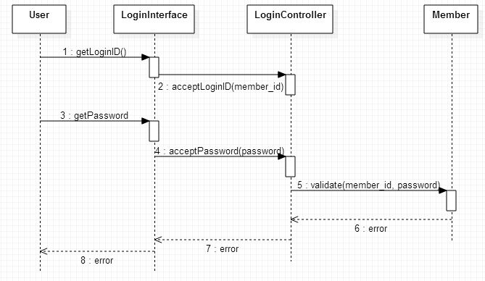

Login: Alternative Flow 1 – Unauthorized Login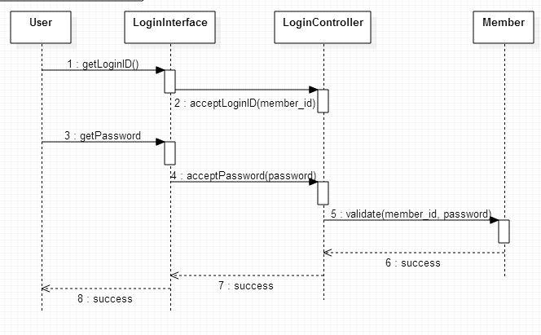

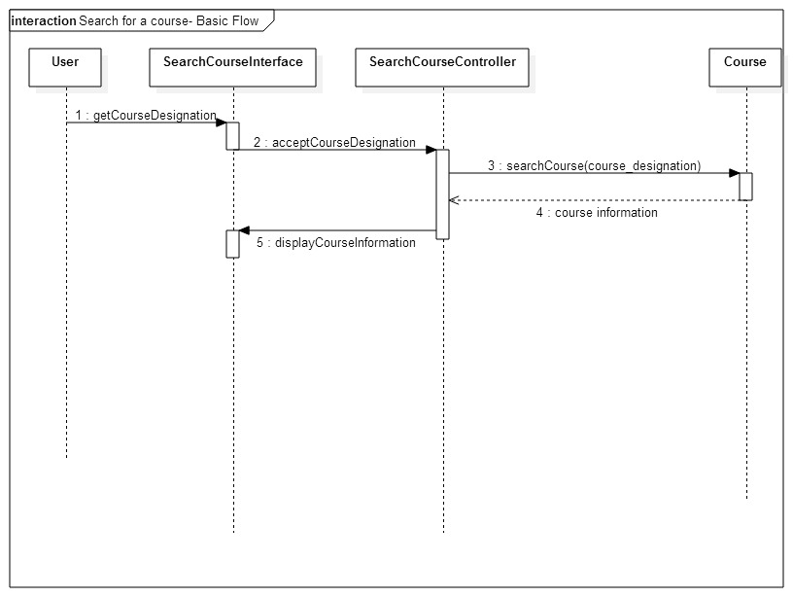

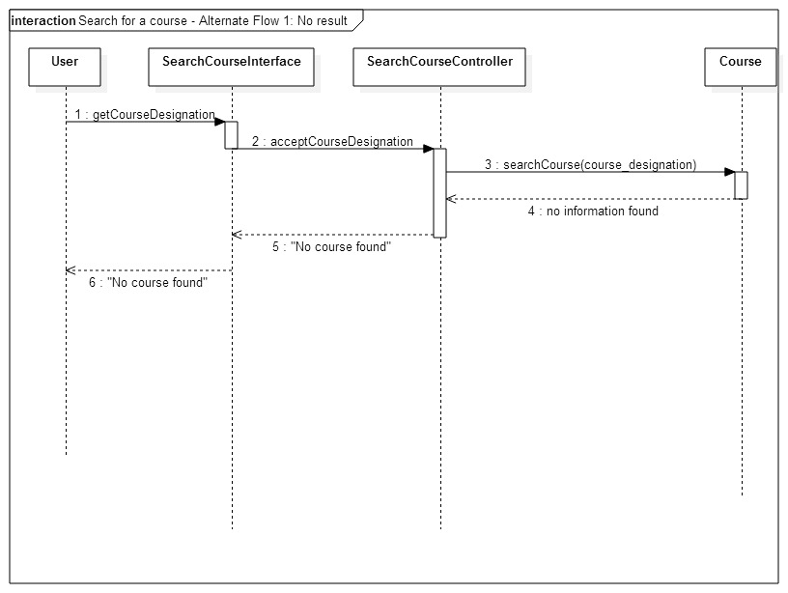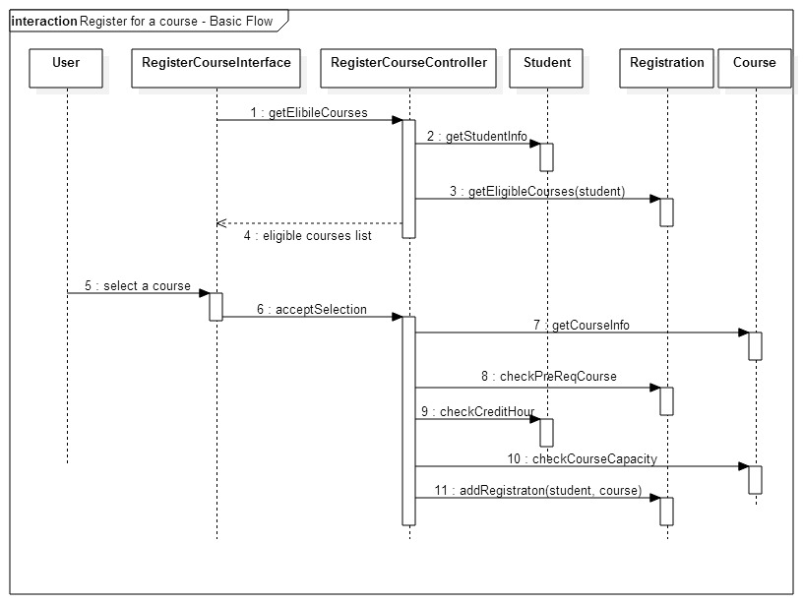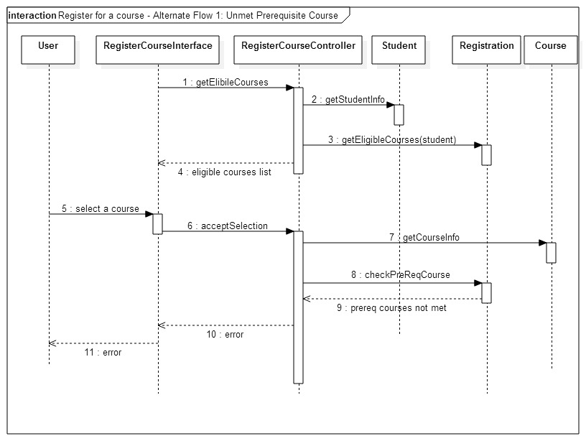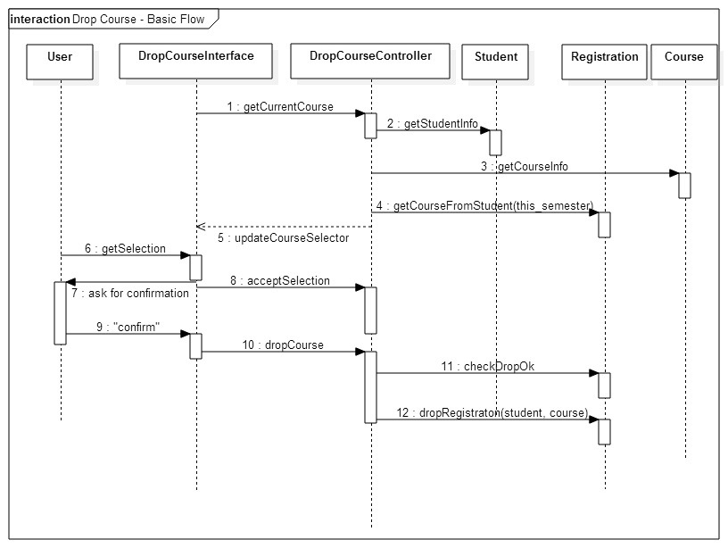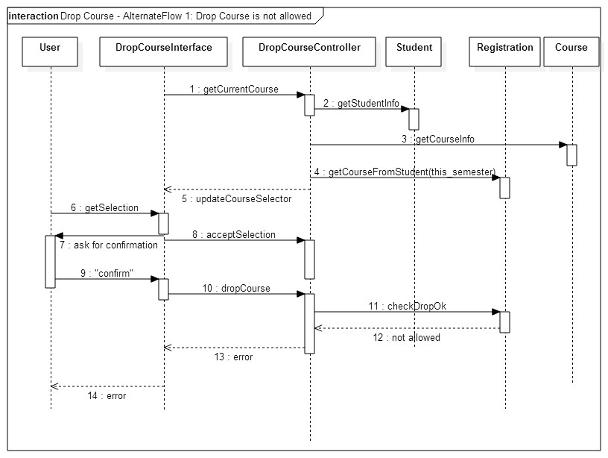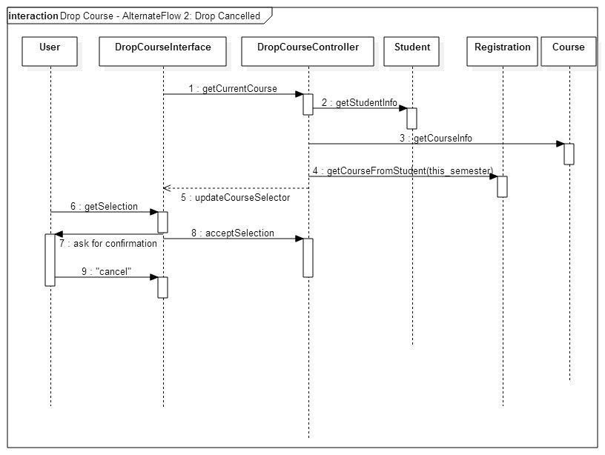

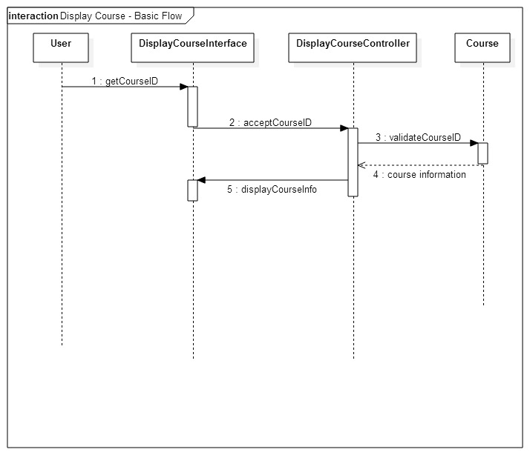

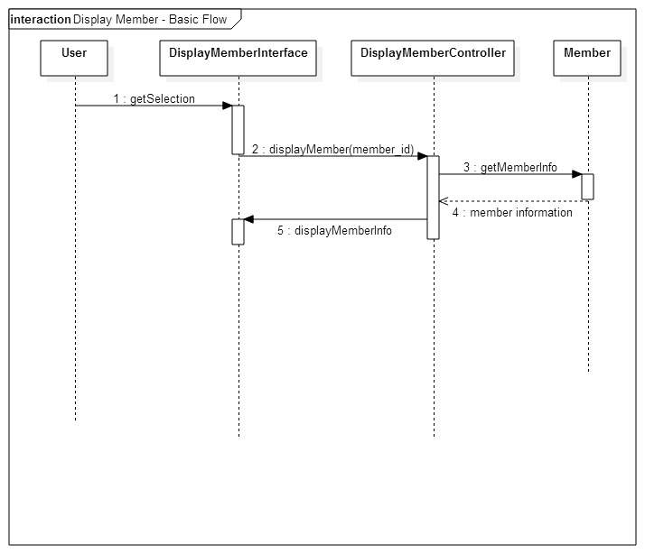

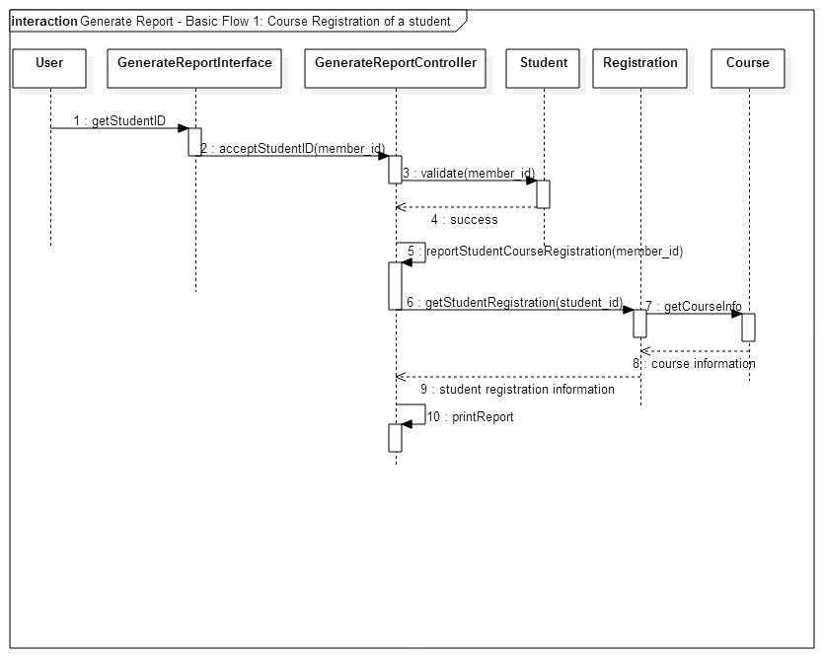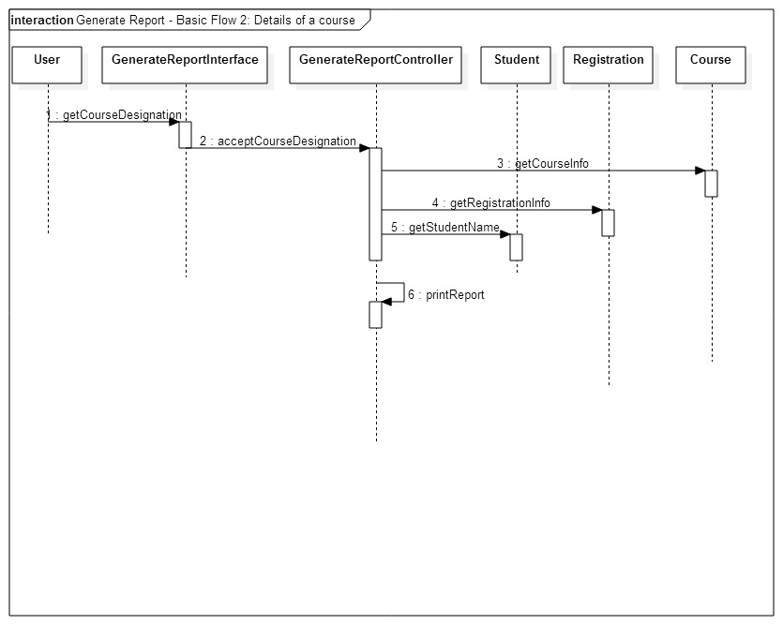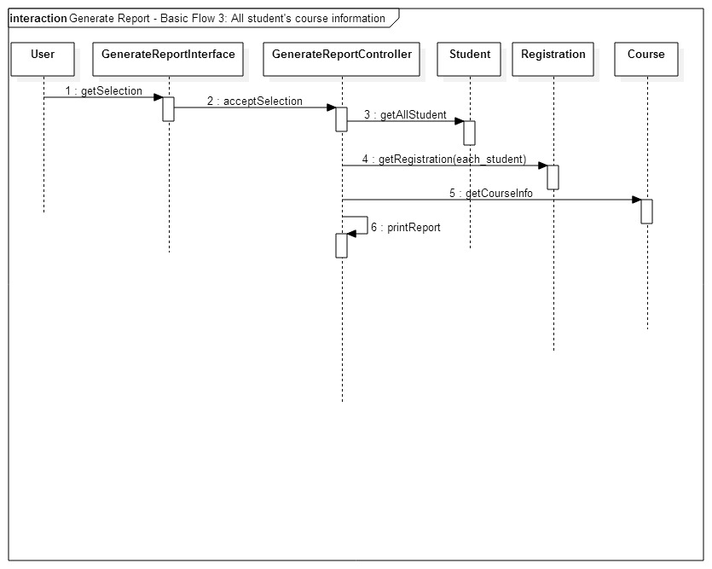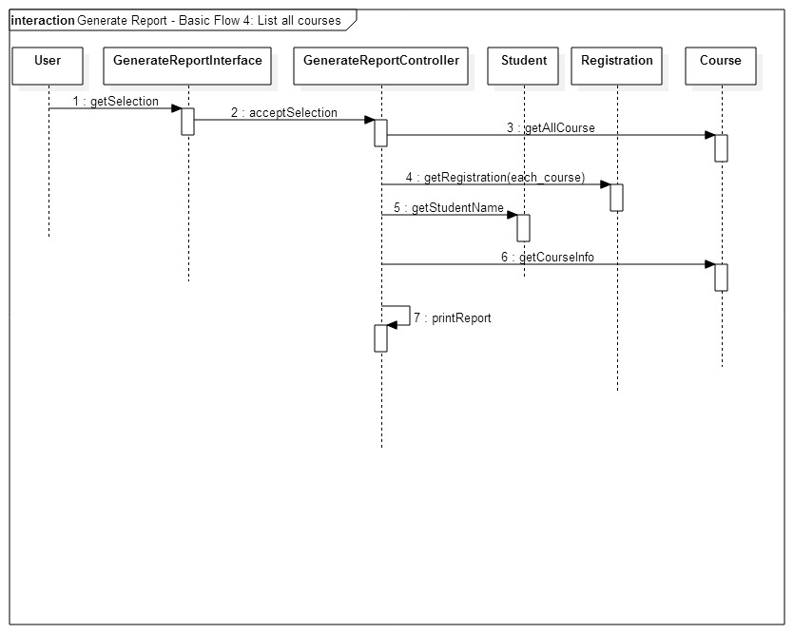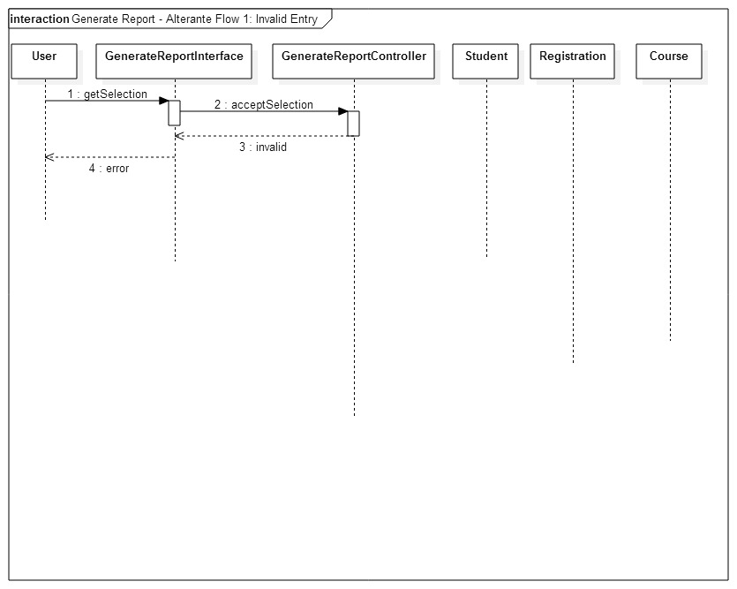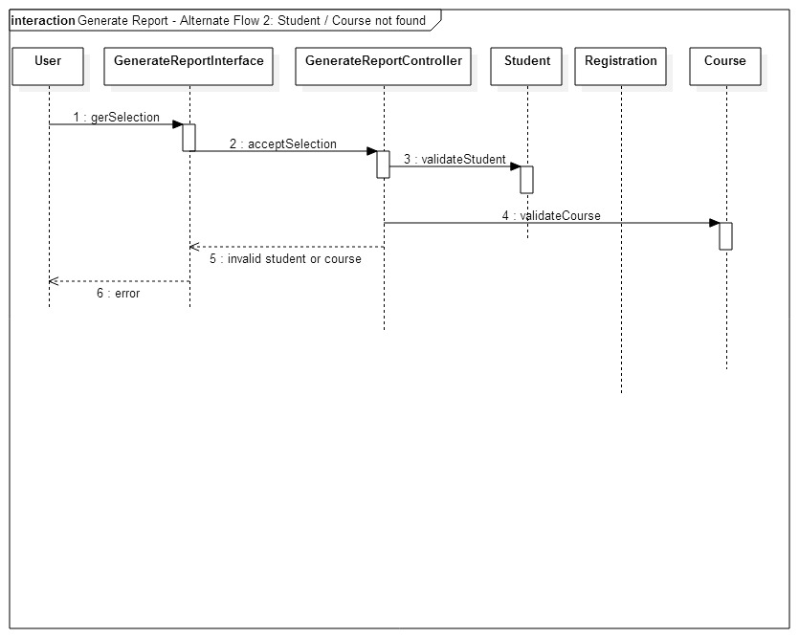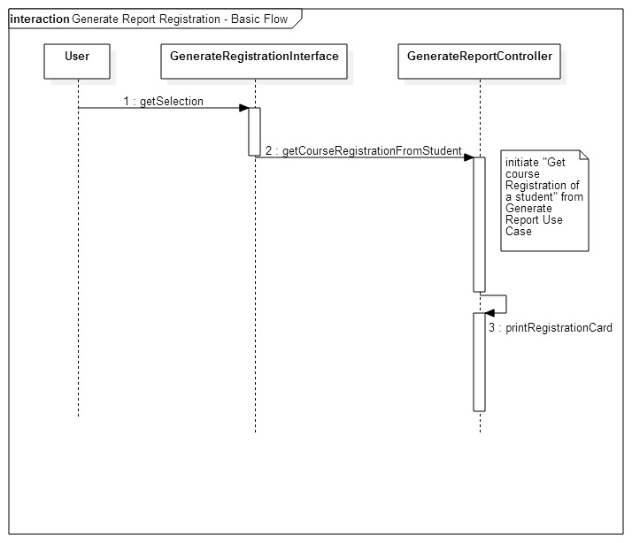

**Class**

**C  
l**

**a**

**s**

**s**

**Class Diagram  
i  
a  
g  
r  
a  
m**

**Activity Diagrams**

The activity diagram for each function will be displayed in the following order:

1. Maintain Member Details
2. Maintain Course Details
3. Maintain Semester Details
4. Maintain Program Details
5. Maintain Department Details
6. Maintain Login Details
7. Login
8. Search for a Course
9. Register for a Course
10. Withdraw/Drop a course
11. Display Course
12. Display Member
13. Generate Report
14. Generate Registration Report/Card (Student)

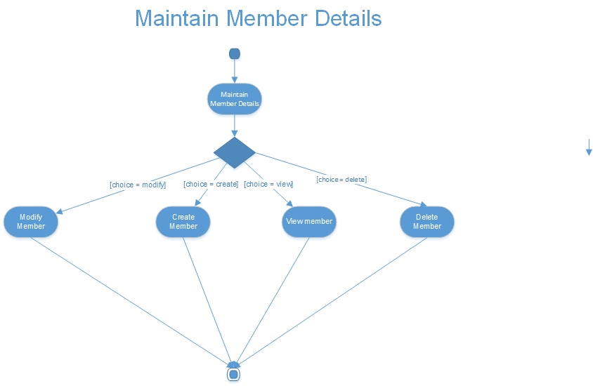

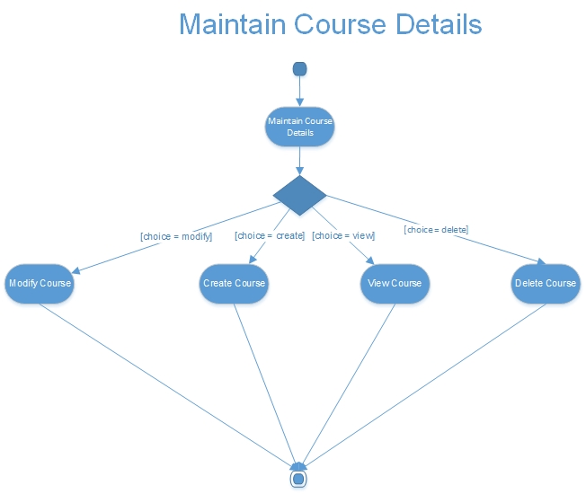

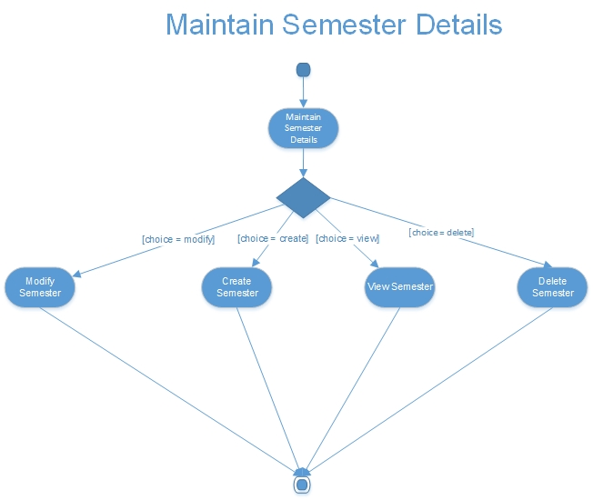

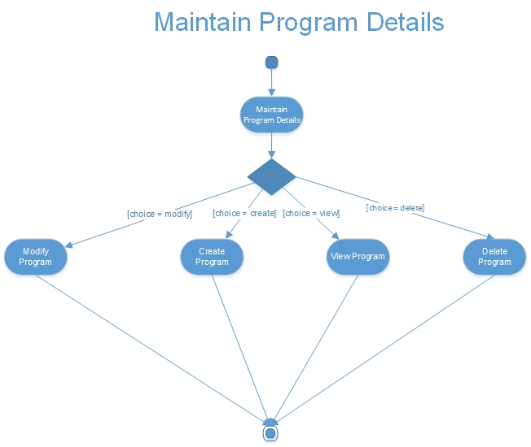

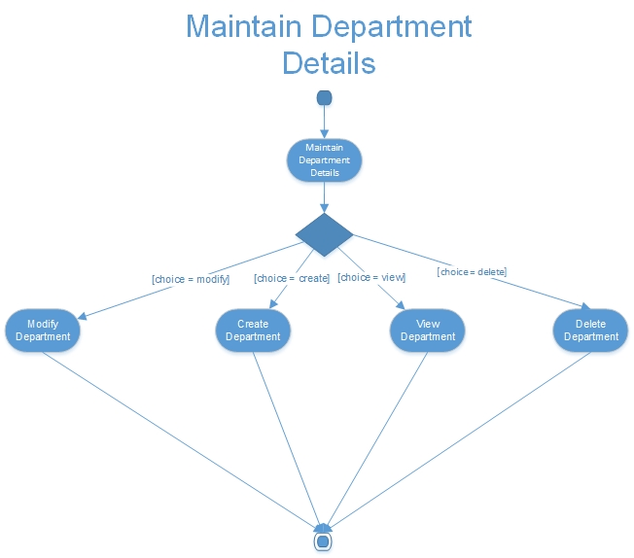

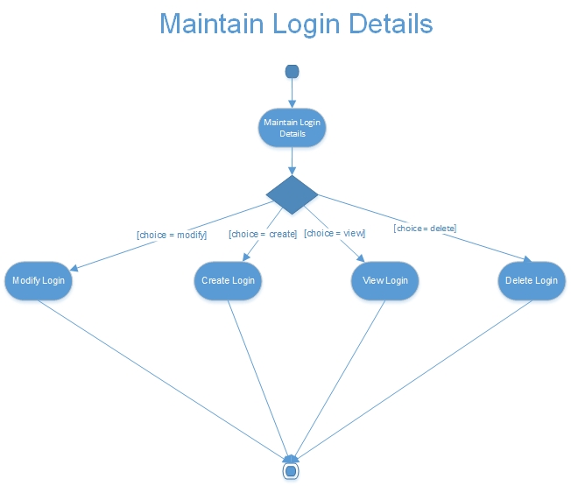

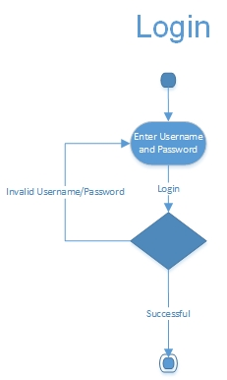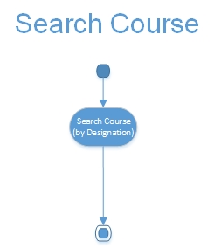

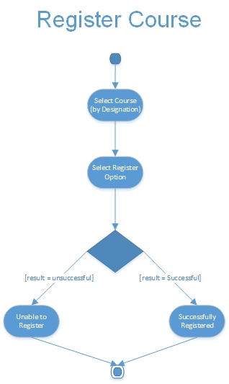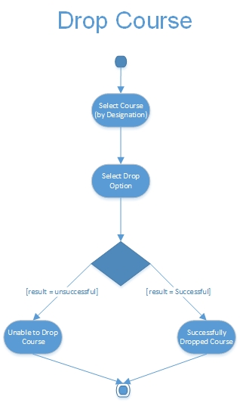

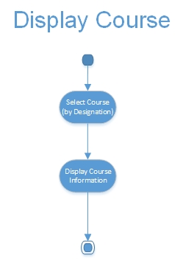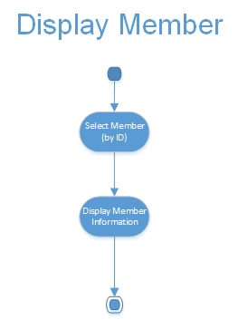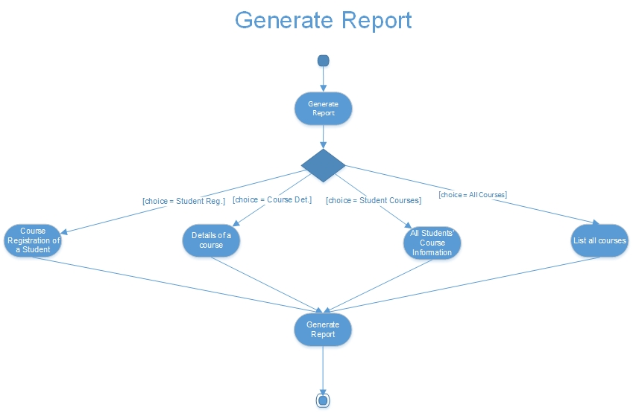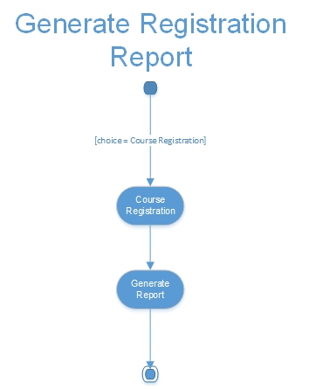

**Statechart Diagrams**

None

**Project Screenshots and Execution Details**

**Screenshots**



**Execution Details**

Please use the cd attached to the final report to view the source code of the project.

The project used Visual Studios 2013 and Microsoft Access 2013 to complete the basic implementation of the system. The created program was implemented using C# and an Access database. Below is the entity-relationship diagram of the database.



**Test Cases**

The test cases will be displayed in the following order:

1. Login
2. Maintain Member Details
3. Maintain Course Details
4. Maintain Semester Details
5. Maintain Program Details
6. Maintain Department Details
7. Maintain Login Details
8. Login
9. Search for a Course
10. Register for a Course
11. Withdraw/Drop a course
12. Display Course
13. Display Member
14. Generate Report
15. Generate Registration Report/Card (Student)

|  |  |  |  |  |  |
| --- | --- | --- | --- | --- | --- |
| **Maintain Member Details** | | | | | |
| Test  Case | Subflow | Inputs | Expected Result | Actual  Result | Comments |
| 1 | Create Member | All Vaild inputs, Student | Succesfully created |  |  |
| 2 | Create Member | All Vaild inputs, Blank First Name Input, Student | Blank Error |  |  |
| 3 | Create Member | All Valid Inputs, Blank Last Name Input, Student | Blank Error |  |  |
| 4 | Create Member | All Valid Inputs, Blank Email Input, Student | Blank Error |  |  |
| 5 | Create Member | All Valid Inputs, First and Last Name > 40 chars, Student | Char Limit Error |  | See Validity Check 2 |
| 6 | Create Member | All Valid Inputs, Email > 80 chars, Student | Char Limit Error |  | See Validity Check 3 |
| 7 | Create Member | All Valid Inputs, Blank Department ID Input, Student | Blank Error |  |  |
| 8 | Create Member | All Valid Inputs, Department Mismatch, Student | Mismatch Error |  |  |
| 9 | Create Member | All Valid Inputs, Blank Program ID Input, Student | Blank Error |  |  |
| 10 | Create Member | All Valid Inputs, Program Mismatch, Student | Mismatch Error |  |  |
| 11 | Create Member | All Valid Inputs, Blank Current Semester, Student | Blank Error |  |  |
| 12 | Create Member | All Valid Inputs, Blank Phone Number, Student | Blank Error |  |  |
| 13 | Create Member | All Valid Inputs, Improperly Formated Phone Number, Student | Format Error |  | See Validity Check 4 |
| 14 | Create Member | All Valid Inputs, Blank Credit Hours, Student | Blank Error |  |  |
| 15 | Create Member | All Valid Inputs, Negative Credit Hours, Student | Negative Hours |  |  |
| 16 | Create Member | All Vaild inputs, Faculty | Succesfully created |  |  |
| 17 | Create Member | All Vaild inputs, Blank First Name Input, Faculty | Blank Error |  |  |
| 18 | Create Member | All Valid Inputs, Blank Last Name Input, Faculty | Blank Error |  |  |
| 19 | Create Member | All Valid Inputs, Blank Email Input, Faculty | Blank Error |  |  |
| 20 | Create Member | All Valid Inputs, First and Last Name > 40 chars, Faculty | Char Limit Error |  | See Validity Check 2 |
| 21 | Create Member | All Valid Inputs, Email > 80 chars, Faculty | Char Limit Error |  | See Validity Check 3 |
| 22 | Create Member | All Valid Inputs, Department Mismatch, Faculty | Mismatch Error |  |  |
| 23 | Create Member | All Valid Inputs, Blank Program ID Input, Faculty | Blank Error |  |  |
| 24 | Create Member | All Valid Inputs, Blank Phone Number, Faculty | Blank Error |  |  |
| 25 | Create Member | All Valid Inputs, Improperly Formated Phone Number, Faculty | Format Error |  | See Validity Check 4 |
| 26 | Modify Member | All Vaild inputs, Student | Succesfully created |  |  |
| 27 | Modify Member | All Vaild inputs, Blank First Name Input, Student | Blank Error |  |  |
| 28 | Modify Member | All Valid Inputs, Blank Last Name Input, Student | Blank Error |  |  |
| 29 | Modify Member | All Valid Inputs, Blank Email Input, Student | Blank Error |  |  |
| 30 | Modify Member | All Valid Inputs, First and Last Name > 40 chars, Student | Char Limit Error |  | See Validity Check 2 |
| 31 | Modify Member | All Valid Inputs, Email > 80 chars, Student | Char Limit Error |  | See Validity Check 3 |
| 32 | Modify Member | All Valid Inputs, Blank Department ID Input, Student | Blank Error |  |  |
| 33 | Modify Member | All Valid Inputs, Department Mismatch, Student | Mismatch Error |  |  |
| 34 | Modify Member | All Valid Inputs, Blank Program ID Input, Student | Blank Error |  |  |
| 35 | Modify Member | All Valid Inputs, Program Mismatch, Student | Mismatch Error |  |  |
| 36 | Modify Member | All Valid Inputs, Blank Current Semester, Student | Blank Error |  |  |
| 37 | Modify Member | All Valid Inputs, Blank Phone Number, Student | Blank Error |  |  |
| 38 | Modify Member | All Valid Inputs, Improperly Formated Phone Number, Student | Format Error |  | See Validity Check 4 |
| 39 | Modify Member | All Valid Inputs, Blank Credit Hours, Student | Blank Error |  |  |
| 40 | Modify Member | All Valid Inputs, Negative Credit Hours, Student | Negative Hours |  |  |
| 41 | Modify Member | All Vaild inputs, Faculty | Succesfully created |  |  |
| 42 | Modify Member | All Vaild inputs, Blank First Name Input, Faculty | Blank Error |  |  |
| 43 | Modify Member | All Valid Inputs, Blank Last Name Input, Faculty | Blank Error |  |  |
| 44 | Modify Member | All Valid Inputs, Blank Email Input, Faculty | Blank Error |  |  |
| 45 | Modify Member | All Valid Inputs, First and Last Name > 40 chars, Faculty | Char Limit Error |  | See Validity Check 2 |
| 46 | Modify Member | All Valid Inputs, Email > 80 chars, Faculty | Char Limit Error |  | See Validity Check 3 |
| 47 | Modify Member | All Valid Inputs, Department Mismatch, Faculty | Mismatch Error |  |  |
| 48 | Modify Member | All Valid Inputs, Blank Program ID Input, Faculty | Blank Error |  |  |
| 49 | Modify Member | All Valid Inputs, Blank Phone Number, Faculty | Blank Error |  |  |
| 50 | Modify Member | All Valid Inputs, Improperly Formated Phone Number, Faculty | Format Error |  | See Validity Check 4 |
| 51 | View Member | Valid user_id | Succesfully Viewed |  |  |
| 52 | View Member | Inalid user_id | Course ID Error |  |  |
| 53 | Delete Member | Valid user_id | Succesfully Deleted |  |  |
| 54 | Delete Member | Inalid user_if | Course ID Error |  |  |
| 55 | Alternative Flow 1 | Modify Cancelled | Restarted |  |  |
| 56 | Alternative Flow 2 | Delete Cancelled | Restarted |  |  |
| 57 | Alternative Flow 3 | User Exits | Back to Previous Screen |  |  |

|  |  |  |  |  |  |  |
| --- | --- | --- | --- | --- | --- | --- |
| **Maintain Course Details** | | | | | | |
| Test  Case | Subflow | Inputs | Expected Result | Actual  Result | | Comments |
| 1 | Create Course | All Vaild inputs | Succesfully created | |  |  |
| 2 | Create Course | All Vaild inputs, Blank Course Designation | Blank Error | |  |  |
| 3 | Create Course | All Valid Inputs, Blank Instructor Input | Blank Error | |  |  |
| 4 | Create Course | All Valid Inputs, Blank Course Title Input | Blank Error | |  |  |
| 5 | Create Course | All Valid Inputs, Course Title > 50 chars | Char Limit Error | |  |  |
| 6 | Create Course | All Valid Inputs, Blank Course Description > 255 chars | Char Limit Error | |  |  |
| 7 | Create Course | All Valid Inputs, Blank Department name Input | Blank Error | |  |  |
| 8 | Create Course | All Valid Inputs, Department Mismatch | Mismatch Error | |  | See Validity Check 7 |
| 9 | Create Course | All Valid Inputs, Blank Schedule Input | Blank Error | |  |  |
| 10 | Create Course | All Valid Inputs, Invalid Schedule Format Input | Format Error | |  |  |
| 11 | Create Course | All Valid Inputs, Blank Max Capacity Input | Blank Error | |  |  |
| 12 | Create Course | All Valid Inputs, Negative Max Capacity Input | Negative Error | |  |  |
| 13 | Create Course | All Valid Inputs, Max Capacity > 300 | Capacity Limit Error | |  |  |
| 14 | Create Course | All Valid Inputs, Inavild ID Input | Format Error | |  |  |
| 15 | Create Course | Course is Not in Current Semester | Semester Error | |  |  |
| 16 | Modify Course | All Vaild inputs | Succesfully Updated | |  |  |
| 17 | Modify Course | All Vaild inputs, Blank Course Designation | Blank Error | |  |  |
| 18 | Modify Course | All Valid Inputs, Blank Instructor Input | Blank Error | |  |  |
| 19 | Modify Course | All Valid Inputs, Blank Course Title Input | Blank Error | |  |  |
| 20 | Modify Course | All Valid Inputs, Course Title > 50 chars | Char Limit Error | |  |  |
| 21 | Modify Course | All Valid Inputs, Blank Course Description > 255 chars | Char Limit Error | |  |  |
| 22 | Modify Course | All Valid Inputs, Blank Department name Input | Blank Error | |  |  |
| 23 | Modify Course | All Valid Inputs, Department Mismatch | Mismatch Error | |  | See Validity Check 7 |
| 24 | Modify Course | All Valid Inputs, Blank Schedule Input | Blank Error | |  |  |
| 25 | Modify Course | All Valid Inputs, Invalid Schedule Format Input | Format Error | |  |  |
| 26 | Modify Course | All Valid Inputs, Blank Max Capacity Input | Blank Error | |  |  |
| 27 | Modify Course | All Valid Inputs, Negative Max Capacity Input | Negative Error | |  |  |
| 28 | Modify Course | All Valid Inputs, Max Capacity > 300 | Capacity Limit Error | |  |  |
| 29 | Modify Course | All Valid Inputs, Inavild ID Input | Format Error | |  |  |
| 30 | Modify Course | Course is Not in Current Semester | Semester Error | |  |  |
| 31 | View Course | Valid Course Designation | Succesfully Viewed | |  |  |
| 32 | View Course | Inalid Course Designation | Course ID Error | |  |  |
| 33 | Delete Course | Valid Course Designation | Succesfully Deleted | |  |  |
| 34 | Delete Course | Inalid Course Designation | Course ID Error | |  |  |
| 35 | Alternative Flow 1 | Modify Cancelled | Restarted | |  |  |
| 36 | Alternative Flow 2 | Delete Cancelled | Restarted | |  |  |
| 37 | Alternative Flow 3 | User Exits | Back to Previous Screen | |  |  |

|  |  |  |  |  |  |  |  |
| --- | --- | --- | --- | --- | --- | --- | --- |
| **Maintain Semester Details** | | | | | | | |
| Test  Case | Subflow | Semester Number | Program | Total Credits | Expected Result | Actual  Result | Comments |
| 1 | Create Semester | Valid | Valid | Valid | Successfully created |  |  |
| 2 | Create Semester | Invalid | - | - | Invalid Semester Number |  |  |
| 3 | Create Semester | NULL | - | - | NULL Semester Number |  |  |
| 4 | Create Semester | Valid | Invalid | - | Invalid Program |  |  |
| 5 | Create Semester | Valid | NULL | - | NULL Program |  |  |
| 6 | Create Semester | Valid | Valid | Invalid | Invalid Total Credits |  |  |
| 7 | Create Semester | Valid | Valid | NULL | Null Total Credits |  |  |
| 8 | Modify Semester | Valid | Valid | Valid | Successfully created |  |  |
| 9 | Modify Semester | Invalid | - | - | Invalid Semester Number |  |  |
| 10 | Modify Semester | NULL | - | - | NULL Semester Number |  |  |
| 11 | Modify Semester | Valid | Invalid | - | Invalid Program |  |  |
| 12 | Modify Semester | Valid | NULL | - | NULL Program |  |  |
| 13 | Modify Semester | Valid | Valid | Invalid | Invalid Total Credits |  |  |
| 14 | Modify Semester | Valid | Valid | NULL | Null Total Credits |  |  |
| 15 | Delete Semester | Valid | - | - | Successfully Deleted |  |  |
| 16 | Delete Semester | Invalid | - | - | Invalid Semester ID |  |  |
| 17 | Delete Semester | NULL | - | - | NULL Semester ID |  |  |
| Test Case | Alternative Subflow | - | - | - | Expected Result | Actual Result | Comments |
| 18 | Modify Cancelled | - | - | - | Use Case is restarted |  |  |
| 19 | Delete Canceled | - | - | - | Use Case is restarted |  |  |
| 20 | User Exits | - | - | - | Returns to Previus Screen |  |  |

|  |  |  |  |  |  |
| --- | --- | --- | --- | --- | --- |
| **Maintain Program Details** | | | | | |
| Test Case | Subflow | Inputs | Expected Result | Actual  Result | Comments |
| 1 | Create Program | All Vaild inputs | Succesfully created |  |  |
| 2 | Create Program | All Vaild inputs, Blank Program Title | Blank Error |  |  |
| 3 | Create Program | All Valid Inputs, Blank Number of Semesters | Blank Error |  |  |
| 4 | Create Program | All Valid Inputs, Blank Duration | Blank Error |  |  |
| 5 | Create Program | All Valid Inputs, Blank Degree Level | Blank Error |  |  |
| 6 | Create Program | All Valid Inputs, Blank Department ID Input | Blank Error |  |  |
| 7 | Create Program | All Valid Inputs, Department Mismatch | Mismatch Error |  |  |
| 8 | Create Program | All Valid Inputs, Program Title > 60 characters | Char Limit Error |  | See Validity Check 1 |
| 9 | Create Program | All Valid Inputs, Degree Level Mismatch | Mismatch Error |  | See Validity Check 3 |
| 14 | Modify Program | All Vaild inputs | Succesfully created |  |  |
| 15 | Modify Program | All Vaild inputs, Blank Program Title | Blank Error |  |  |
| 16 | Modify Program | All Valid Inputs, Blank Number of Semesters | Blank Error |  |  |
| 17 | Modify Program | All Valid Inputs, Blank Duration | Blank Error |  |  |
| 18 | Modify Program | All Valid Inputs, Blank Degree Level | Blank Error |  |  |
| 19 | Modify Program | All Valid Inputs, Blank Department ID Input | Blank Error |  |  |
| 20 | Modify Program | All Valid Inputs, Department Mismatch | Mismatch Error |  |  |
| 21 | Modify Program | All Valid Inputs, Program Title > 60 characters | Char Limit Error |  | See Validity Check 1 |
| 22 | Modify Program | All Valid Inputs, Degree Level Mismatch | Mismatch Error |  | See Validity Check 3 |
| 26 | View Program | Valid Program ID | Succesfully Viewed |  |  |
| 27 | View Program | Inalid Program ID | Program ID Error |  |  |
| 28 | Delete Program | Valid Program ID | Succesfully Deleted |  |  |
| 29 | Delete Program | Inalid Program ID | Program ID Error |  |  |
| 30 | Alternative Flow 1 | Modify Cancelled | Restarted |  |  |
| 31 | Alternative Flow 2 | Delete Cancelled | Restarted |  |  |
| 32 | Alternative Flow 3 | User Exits | Back to Previous Screen |  |  |

|  |  |  |  |  |  |  |
| --- | --- | --- | --- | --- | --- | --- |
| **Maintain Department Details** | | | | | | |
| Test  Case | Subflow | Department  Name | Department  ID | Expected Result | Actual  Result | Comments |
| 1 | Create Department | Valid | Valid | Successfully created |  |  |
| 2 | Create Department | Valid | Invalid | Invalid Department ID |  |  |
| 3 | Create Department | Valid | NULL | NULL Department ID |  |  |
| 4 | Create Department | Invalid | Valid | Invalid Department Name |  |  |
| 5 | Create Department | Invalid | Invalid | Invalid Department Name & Department ID |  |  |
| 6 | Create Department | Invalid | NULL | Invalid Department Name & NULL Department ID |  |  |
| 7 | Create Department | NULL | Valid | NULL Department Name |  |  |
| 8 | Create Department | NULL | Invalid | NULL Department Name & Invalid Department ID |  |  |
| 9 | Create Department | NULL | NULL | NULL Department Name & NULL Department ID |  |  |
| 10 | Modify Department | Valid | Valid | Successfully Modified |  |  |
| 11 | Modify Department | Valid | Invalid | Invalid Department ID |  |  |
| 12 | Modify Department | Valid | NULL | NULL Department ID |  |  |
| 13 | Modify Department | Invalid | Valid | Invalid Department Name |  |  |
| 14 | Modify Department | Invalid | Invalid | Invalid Department Name & Department ID |  |  |
| 15 | Modify Department | Invalid | NULL | Invalid Department Name & NULL Department ID |  |  |
| 16 | Modify Department | NULL | Valid | NULL Department Name |  |  |
| 17 | Modify Department | NULL | Invalid | NULL Department Name & Invalid Department ID |  |  |
| 18 | Modify Department | NULL | NULL | NULL Department Name & NULL Department ID |  |  |
| 19 | Delete Department | Valid | Valid | Successfully Deleted |  |  |
| 20 | Delete Department | Valid | Invalid | Invalid Department ID |  |  |
| 21 | Delete Department | Valid | NULL | NULL Department ID |  |  |
| 22 | Delete Department | Invalid | Valid | Invalid Department Name |  |  |
| 23 | Delete Department | Invalid | Invalid | Invalid Department Name & Department ID |  |  |
| 24 | Delete Department | Invalid | NULL | Invalid Department Name & NULL Department ID |  |  |
| 25 | Delete Department | NULL | Valid | NULL Department Name |  |  |
| 26 | Delete Department | NULL | Invalid | NULL Department Name & Invalid Department ID |  |  |
| 27 | Delete Department | NULL | NULL | NULL Department Name & NULL Department ID |  |  |
| 19 | View Department | Valid | Valid | Successfully Deleted |  |  |
| 20 | View Department | Valid | Invalid | Invalid Department ID |  |  |
| 21 | View Department | Valid | NULL | NULL Department ID |  |  |
| 22 | View Department | Invalid | Valid | Invalid Department Name |  |  |
| 23 | View Department | Invalid | Invalid | Invalid Department Name & Department ID |  |  |
| 24 | View Department | Invalid | NULL | Invalid Department Name & NULL Department ID |  |  |
| 25 | View Department | NULL | Valid | NULL Department Name |  |  |
| 26 | View Department | NULL | Invalid | NULL Department Name & Invalid Department ID |  |  |
| 27 | View Department | NULL | NULL | NULL Department Name & NULL Department ID |  |  |
| Test Case | Alternative Subflow | - | - | Expected Result | Actual Result | Comments |
| 28 | Modify Cancelled | - | - | - | Use Case is restarted |  |
| 29 | Delete Canceled | - | - | - | Use Case is restarted |  |
| 30 | User Exits | - | - | - | Returns to Prevois Screen |  |

|  |  |  |  |  |  |  |  |
| --- | --- | --- | --- | --- | --- | --- | --- |
| **Maintain Login Details** | | | | | | | |
| Test  Case | Subflow | Username | Password | Role | Expected Result | Actual  Result | Comments |
| 1 | Create Login | Valid | Valid | Admin/Faculty/Student/D.E.O. | Successfully created |  | Invalid username -> # chars not within [4,20] AND Invalid password -> #chars not within [5,30] |
| 2 | Create Login | Valid | Invalid | Admin/Faculty/Student/D.E.O. | Invalid Passowrd |  |  |
| 3 | Create Login | Valid | NULL | Admin/Faculty/Student/D.E.O. | NULL Password |  |  |
| 4 | Create Login | Invalid | Valid | Admin/Faculty/Student/D.E.O. | Invalid Username |  |  |
| 5 | Create Login | Invalid | Invalid | Admin/Faculty/Student/D.E.O. | Invalid Username & Password |  |  |
| 6 | Create Login | Invalid | NULL | Admin/Faculty/Student/D.E.O. | Invalid Username & NULL Password |  |  |
| 7 | Create Login | NULL | Valid | Admin/Faculty/Student/D.E.O. | NULL Username |  |  |
| 8 | Create Login | NULL | Invalid | Admin/Faculty/Student/D.E.O. | NULL Username & Invalid Password |  |  |
| 9 | Create Login | NULL | NULL | Admin/Faculty/Student/D.E.O. | NULL Username & NULL Password |  |  |
| 10 | Modify Login | Valid | Valid | Admin/Faculty/Student/D.E.O. | Successfully Modified |  | Invalid username -> # chars not within [4,20] AND Invalid password -> #chars not within [5,30] |
| 11 | Modify Login | Valid | Invalid | Admin/Faculty/Student/D.E.O. | Invalid Passowrd |  |  |
| 12 | Modify Login | Valid | NULL | Admin/Faculty/Student/D.E.O. | NULL Password |  |  |
| 13 | Modify Login | Invalid | Valid | Admin/Faculty/Student/D.E.O. | Invalid Username |  |  |
| 14 | Modify Login | Invalid | Invalid | Admin/Faculty/Student/D.E.O. | Invalid Username & Password |  |  |
| 15 | Modify Login | Invalid | NULL | Admin/Faculty/Student/D.E.O. | Invalid Username & NULL Password |  |  |
| 16 | Modify Login | NULL | Valid | Admin/Faculty/Student/D.E.O. | NULL Username |  |  |
| 17 | Modify Login | NULL | Invalid | Admin/Faculty/Student/D.E.O. | NULL Username & Invalid Password |  |  |
| 18 | Modify Login | NULL | NULL | Admin/Faculty/Student/D.E.O. | NULL Username & NULL Password |  |  |
| 19 | Delete Login | Valid | - | - | Successfully Deleted |  | Invalid username -> # chars not within [4,20] AND Invalid password -> #chars not within [5,30] |
| 20 | Delete Login | Invalid | - | - | Invalid Username |  |  |
| 21 | Delete Login | NULL | - | - | NULL Username |  |  |
| Test Case | Alternative Subflow | - | - | - | Expected Result | Actual Result | Comments |
| 23 | Modify Cancelled | - | - | - | Use Case is restarted |  |  |
| 24 | Delete Canceled | - | - | - | Use Case is restarted |  |  |
| 25 | User Exits | - | - | - | Returns to Prevois Screen |  |  |

|  |  |  |  |  |  |
| --- | --- | --- | --- | --- | --- |
| **Log In** | | | | | |
| Test  Case | Username | Password | Expected Result | Actual Result | Comments |
| 1 | Valid | Valid | Successful |  |  |
| 2 | Valid | Invalid | DB Error |  |  |
| 3 | Invalid | Valid | DB Error |  |  |
| 4 | Invalid | Invalid | DB Error |  |  |
| 5 | Valid | NULL | NULL Error |  |  |
| 6 | Invalid | NULL | NULL Error |  |  |
| 7 | NULL | Valid | NULL Error |  |  |
| 8 | # Chars < 3 || # Chars >20 | Invalid | Character Limit Error |  |  |
| 9 | # Chars < 3 || # Chars >20 | Valid | Character Limit Error |  |  |
| 10 | # Chars < 3 || # Chars >20 | NULL | Character Limit Error && NULL ERROR |  |  |
| 11 | # Chars < 3 || # Chars >20 | # Chars < 5 || # Chars >50 | Character Limit Error |  |  |
| 12 | Valid | # Chars < 5 || # Chars >51 | Character Limit Error |  |  |
| 13 | Invalid | # Chars < 5 || # Chars >52 | Character Limit Error |  |  |
| 14 | NULL | # Chars < 5 || # Chars >53 | Character Limit Error & NULL ERROR |  |  |

|  |  |  |  |  |
| --- | --- | --- | --- | --- |
| **Search Course** | | | | |
| Test Case | Course Designation | Expected Result | Actual Result | Comments |
| 1 | Valid | Course Displayed | Course Displayed |  |
| 2 | Invalid | Invalid Course Designation | No Course Found |  |
| 3 | NULL | Null Course Designation | No Course Found |  |
| Test Case | Other | Expected Result | Actual Result | Comments |
| 4 | User Exites | Return to Previous Menu | Return to Home Page |  |

|  |  |  |  |  |  |  |
| --- | --- | --- | --- | --- | --- | --- |
| **Register for a Course** | | | | | | |
| Test Case | Course  Designation | Schedule | Prerequisite  met? | Expected Result | Actual Result | Comments |
| 1 | Valid | No Conflict | Yes | Successful Registration |  | Assuming N/A for courses are considered as a "Yes" |
| 2 | Valid | Conflict | Yes | Schedule Conflict |  |  |
| 3 | Invalid | No Conflict | Yes | Invalid Course Designation |  | Invalid = NULL |
| 4 | Invalid | Conflict | Yes | Invalid Course Designation & Schedule Conflict |  |  |
| 5 | Valid | No Conflict | No | Unmet Prerequisite Course |  |  |
| 6 | Valid | Conflict | No | Schedule Conflict & Unmet Prerequisite Course |  |  |
| 7 | Invalid | No Conflict | No | Invalid Course Designation & Unmet Prerequisite Course |  |  |
| 8 | Invalid | Conflict | No | Invalid Course Designation & Schedule Conflict, Unmet Prerequisite Course |  |  |
| 9 | NULL | N/A | N/A | Null Course Designation |  |  |

|  |  |  |  |  |  |
| --- | --- | --- | --- | --- | --- |
| **Drop Course** | | | | | |
| Test Case | Course Option | Drop Allowed? | Expected Result | Actual Result | Comments |
| 1 | Selected | Yes | Dropped Successfully | Course is dropped |  |
| 2 | Selected | No | Drop Not Allowed | N/A | Course can always be dropped |
| 3 | Not Selected | N/A | No Course Selected | "No course found" |  |
| Test Case | Alternative Flow | - | Expected Result | Actual Result | Comments |
| 4 | Drop Cancelled | - | Restarted | No course dropped |  |
| 5 | User Exites | - | Return to Previous Menu | Returned |  |
|  |  |  |  |  |  |

|  |  |  |  |  |
| --- | --- | --- | --- | --- |
| **Display Course** | | | | |
| Test Case | Course Designation | Expected Result | Actual Result | Comments |
| 1 | Valid | Course Information Displayed | Course displayed |  |
| 2 | Invalid | Invalid Course Designation | No Course found |  |
| 3 | NULL | Null Course Designation | No Course found |  |
| Test Case | Other | Expected Result | Actual Result | Comments |
| 4 | User Exites | Return to Previous Menu | Returned |  |

|  |  |  |  |  |
| --- | --- | --- | --- | --- |
| **Display Member** | | | | |
| Test  Case | Member ID | Expected Result | Actual Result | Comments |
| 1 | Valid | Member Information Displayed |  |  |
| 2 | Invalid | Invalid Member ID |  |  |
| 3 | NULL | Null Member ID |  |  |
| Test Case | Other | Expected Result | Actual Result | Comments |
| 4 | User Exites | Return to Previous Menu |  |  |

|  |  |  |  |  |  |  |
| --- | --- | --- | --- | --- | --- | --- |
| **Generate Report** | | | | | | |
| Test  Case | Subflow | Student ID | Course  Designation | Expected Result | Actual Result | Comments |
| 1 | Report Registration of Student | Valid | Valid | Generates Report of Courses for Student | Actual Result | Comments |
| 2 | Report Registration of Student | Valid | Invalid | Generates Report of Courses for Student | Report Generated | Course Designation Should Not affect the Report. |
| 3 | Report Registration of Student | Valid | NULL | Generates Report of Courses for Student | Report Generated |  |
| 4 | Report Registration of Student | Invalid | Valid | Generates Report of Courses for Student | Report Generated |  |
| 5 | Report Registration of Student | Invalid | Invalid | Generates Report of Courses for Student | No student found |  |
| 6 | Report Registration of Student | Invalid | NULL | Generates Report of Courses for Student | No student found |  |
| 7 | Report Registration of Student | NULL | NULL | Error NULL ID | No student found |  |
| 8 | Details of Course | Valid | Valid | Generates Report of Course Details | Do not accept inputs |  |
| 9 | Details of Course | Valid | Invalid | Generates Report of Course Details | Report Generated |  |
| 10 | Details of Course | Valid | NULL | Generates Report of Course Details | No offer this semester |  |
| 11 | Details of Course | Invalid | Valid | Generates Report of Course Details | Do not accept inputs |  |
| 12 | Details of Course | Invalid | Invalid | Generates Report of Course Details | Report Generated |  |
| 13 | Details of Course | Invalid | NULL | Generates Report of Course Details | No offer this semester |  |
| 14 | Details of Course | NULL | NULL | Error NULL Course Designation | Do not accept inputs |  |
| 15 | Report All Students | Valid | Valid | Generates Report for All Students | Do not accept inputs |  |
| 16 | Report All Students | Valid | Invalid | Generates Report for All Students | Report Generated | May not need every case for subflow |
| 17 | Report All Students | Valid | NULL | Generates Report for All Students | Report Generated |  |
| 18 | Report All Students | Invalid | Valid | Generates Report for All Students | Report Generated |  |
| 19 | Report All Students | Invalid | Invalid | Generates Report for All Students | Report Generated |  |
| 20 | Report All Students | Invalid | NULL | Generates Report for All Students | Report Generated |  |
| 21 | Report All Courses | Valid | Valid | Generates Report for All Courses | Report Generated |  |
| 22 | Report All Courses | Valid | Invalid | Generates Report for All Courses | Report Generated | May not need every case for subflow |
| 23 | Report All Courses | Valid | NULL | Generates Report for All Courses | Report Generated |  |
| 24 | Report All Courses | Invalid | Valid | Generates Report for All Courses | Report Generated |  |
| 25 | Report All Courses | Invalid | Invalid | Generates Report for All Courses | Report Generated |  |
| 26 | Report All Courses | Invalid | NULL | Generates Report for All Courses | Report Generated |  |
| Test Case | Alternative Subflow | - | - | Expected Result | Report Generated |  |
| 27 | User Exits | - | - | Return to Previous Menu | Actual Result | Comments |

|  |  |  |  |  |
| --- | --- | --- | --- | --- |
| **Generate Report Registration** | | | | |
| Test Case | Member ID | Expected Result | Actual Result | Comments |
| 1 | Valid | Member Information Displayed | Report generated |  |
| 2 | Invalid | Invalid Member ID | N/A | Member ID has to be valid after log in |
| 3 | NULL | Null Member ID | N/A | Member ID has to be valid after log in |
| Test Case | Other | Expected Result | Actual Result | Comments |
| 4 |  | Return to Previous Menu | Returned |  |

**Presentation Details**

**Note:** Not all information may be used in the presentation, but it is here for easy access.

|  |  |  |  |
| --- | --- | --- | --- |
| Login Information | | | |
| Name | Username | Password | Role |
| Jane Doe | jdoe | bluegill | student |
| Mary Jane | mjane | umbrella | student |
| <Administrator> | stom5 | admin | administrator |
| <data entry operator> | kcollins | dataentry | data entry operator |
| Danielle Jackson | djackson | thames | faculty |
| Robert Thornburgh | rthorn | 889collie | faculty |

**Brief Information about database**:

Jane Doe is a first semester student in the computer science BS program.

Mary Jane is a second semester student in the computer BS program. She has completed her first semester at this university, but didn’t pass one of her courses in the first semester (MATH165)-this means she cannot take MATH166 in the current semester.

Danielle Jackson is a faculty member in the computer science department. She teaches CSCI230 and CSCI240 (Computing I and II).

Robert t Thornburgh is a faculty member in the math department. He teaches MATH165 and MATH166 (Calculus I and II).

There is one course in the database that is so “old” it is no longer being taught-CSCI120, “Windows on Computer.” This course could should some potential features of the system, like delete or modify course.

**Division of Work**

Here is what work each project member completed during the course of this project.

Note: All members participated fully in constructing the initial requirements document.

1. Kaitlyn Davis
   1. Created the following use case descriptions:
      1. drop course
      2. maintain member details
      3. maintain program details
      4. maintain semester details
      5. maintain login details
      6. maintain department details
      7. generate registration report
      8. display member
   2. Complied:
      1. Class diagrams
      2. . Software Requirements Specification
      3. Final Report
   3. Completed good portion of SRS and final report (excluding diagrams/test cases)
   4. Dealt with database design and creation.
   5. Created final class and use case diagrams
   6. Assisted with queries for the URS system
2. Nhan Do
   1. Created the following use case descriptions/class diagrams:
      1. login
      2. generate report
   2. Implemented the following functions:
      1. Login
      2. Search Course
      3. Drop Course
      4. Register Course
      5. Generate Report
      6. Generate Registration Report
      7. Maintain Course
      8. Maintain Member Details (Student/Faculty)
      9. View Courses
   3. Created sequence diagrams for all 14 functions
   4. Assisted Kaitlyn with completing portions of the SRS
3. Emilio Lopez
   1. Created the following use case descriptions/class diagrams:
      1. Register Course
      2. Search Course
   2. Created activity diagrams for all 14 functions
   3. Contributed towards Final Presentation PowerPoint
   4. Created the following test cases:
      1. Maintain Department Details
      2. Maintain Course Details
      3. Maintain Login Details
      4. Generate Report
      5. Display Course
      6. Drop Course
      7. Search Course
      8. Register Course
      9. Login
4. Andrew Meyer
   1. Created the following use case descriptions/class diagrams:
      1. Display Course
      2. Maintain Course Details
   2. Created the following test cases:
      1. Generate Report
      2. Display Member
      3. Maintain Member Details
      4. Maintain Program Details
      5. Maintain Semester Detailss

**Index**

* Activity Diagrams. 87
* Assumptions, 9
* Constraints, 9
* Execution Details, 97
* External Requirements, 10
* Functional Requirements, 17
* Introduction, 5
* Overall Description, 6,7
* Product Functions, 9
* Project Screen Shots, 96
* Sequence Diagrams, 48
* Test Cases, 98
  + Display Course, 113
  + Display Member, 114
  + Drop Course, 113
  + Login, 111
  + Maintain Course, 102
  + Maintain Department, 107
  + Maintain Login, 109
  + Maintain Member, 99
  + Maintain Program, 105
  + Maintain Semester, 104
  + Register Course, 112
  + Search Course, 112
* UML Diagrams, 47
* User Characteristics, 9